11

Managing Hyper-V

This chapter covers the following recipes:

* Installing Hyper-V inside Windows Server
* Creating a Hyper-V VM
* Using PowerShell Direct
* Using Hyper-V VM Groups
* Configuring VM Hardware
* Configuring VM Networking
* Implementing Nested Virtualization
* Managing VM state
* Managing Storage Movement
* Configure VM replication
* Manage VM Checkpoints
* Clustering Hyper-V servers

# Introduction

Hyper-V is Microsoft's virtual machine (VM) hypervisor. Microsoft has made Hyper-V available in all versions of Windows Server 2022 and the Enterprise, Professional, and Education editions of Windows 11. Windows Server 2022 and Windows 11 include Hyper-V as an option you can install.

Microsoft first released Hyper-V with Server 2008 and has improved it significantly with each successive version of Windows Server. Improvements include features, support for the latest hardware, and significantly increased scalability.

A useful feature of Hyper-V is nested virtualization, the ability to run Hyper-V inside a Hyper-V VM. Nested virtualization has some good use cases, such as in training. You could give each student a VM on a large blade containing the VMs needed for the course labs. Nested virtualization also provides an additional layer of security that might be useful in multi-tenant scenarios.

Microsoft at one time shipped a free version of Hyper-V, the Microsoft Hyper-V Server. The Hyper-V Server runs VMs with no GUI. You configure and manage remotely using recipes like the ones in this chapter. The product was free, although you did need to license any guest VMs. For Server 2022, Microsoft has dropped this. You can now only use Hyper-V inside Windows 11 or Windows Server.

This chapter starts with installing and configuring the Hyper-V feature. After installing Hyper-V, you go on to create a VM, PSDirect, which requires you to download an ISO image of Windows Server from the internet.

After you create the PSDirect VM, you use the VM. You use PowerShell Direct to use a remoting session into a VM without a network connection. You also configure a VM's hardware and networking capability. You then use the PowerShell cmdlets to manage the state of a VM.

Hyper-V allows you to move a VM and/or a VM's storage between Hyper-V hosts. For disaster recovery, you can replicate a running VM (and use that replica should the primary VM fail).

You can take snapshots, or checkpoints, of a VM to save a VM's state and restore your VM to that point, as you can see in the Managing VM checkpoints recipe.

## The systems used in the chapter

This chapter uses two Hyper-V host systems, HV1 and HV2 – both domain-joined servers in the Reskit.Org domain. You also use a domain-joined host, SRV1. Finally, you make use of a domain controller in the domain (DC1), so that host must on line as well. The hosts used in this chapter are as shown here:

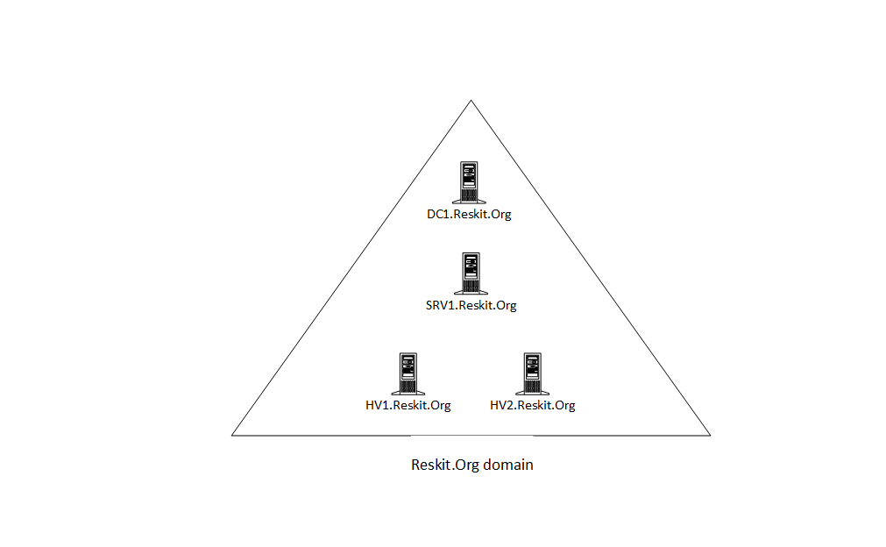

Figure 11.1: Host in use for this chapter

Insert image B18878_11_01.png

# Installing Hyper-V inside Windows Server

In Windows Server, Hyper-V is a Windows feature you can add using the Install-WindowsFeature cmdlet. You also have the choice of whether to add the Hyper-V Management tools. These tools include the Hyper-V Manager GUI tool and the PowerShell cmdlets you use in this chapter.

Once you have installed Hyper-V, you must reboot to complete the installation. Once fully installed, you can configure the Hyper-V and Hyper-V VMs using PowerShell, as you can see in later recipes in this chapter.

## Getting ready

You run this recipe on HV1 after you have installed PowerShell 7. You must also have HV2 online and likewise configured.

## How to do it...

1. Installing the Hyper-V feature on HV1, HV2

$InstallSB = {

  Install-WindowsFeature -Name Hyper-V -IncludeManagementTools

}

Invoke-Command -ComputerName HV1, HV2 -ScriptBlock $InstallSB

1. Rebooting the servers to complete the installation

Restart-Computer -ComputerName HV2 -Force

Restart-Computer -ComputerName HV1 -Force

1. Creating a PSSession with both HV Servers (after reboot)

$Sessions = New-PSSession HV1, HV2

1. Creating and setting the location for VMs and VHDs on HV1 and HV2

$ConfigSB1 = {

    New-Item -Path C:\VM -ItemType Directory -Force |

        Out-Null

    New-Item -Path C:\VM\VHDS -ItemType Directory -Force |

        Out-Null

    New-Item -Path C:\VM\VMS -ItemType Directory -force |

        Out-Null

}

Invoke-Command -ScriptBlock $ConfigSB1 -Session $Sessions |

  Out-Null

1. Setting default paths for Hyper-V VM disk/config information

$ConfigSB2 = {

  $VHDS = 'C:\VM\VHDS'

  $VMS  = 'C:\VM\VMS'

  Set-VMHost -ComputerName Localhost -VirtualHardDiskPath $VHDS

  Set-VMHost -ComputerName Localhost -VirtualMachinePath $VMS

}

Invoke-Command -ScriptBlock $ConfigSB2 -Session $Sessions

1. Setting NUMA spanning

$ConfigSB3 = {

  Set-VMHost -NumaSpanningEnabled $true

}

Invoke-Command -ScriptBlock $ConfigSB3 -Session $Sessions

1. Setting EnhancedSessionMode

$ConfigSB4 = {

 Set-VMHost -EnableEnhancedSessionMode $true

}

Invoke-Command -ScriptBlock $ConfigSB4 -Session $Sessions

1. Setting host resource metering on HV1, HV2

$ConfigSB5 = {

 $RMInterval = New-TimeSpan -Hours 0 -Minutes 15

 Set-VMHost -ResourceMeteringSaveInterval $RMInterval

}

Invoke-Command -ScriptBlock $ConfigSB5 -Session $Sessions

1. Reviewing key VM host settings

$CheckVMHostSB = {

  Get-VMHost

}

$Properties = 'Name', 'V*Path','Numasp*', 'Ena*','RES*'

Invoke-Command -Scriptblock $CheckVMHostSB -Session $Sessions |

  Format-Table -Property $Properties

## How it works...

In step 1, you install the Hyper-V feature to both HV1 and HV2. The output from this step looks like this:

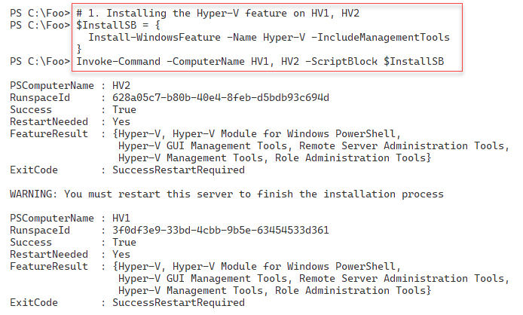

Figure 11.2: Installing Hyper-V on HV1 and HV2

Insert image B18878_11_02.png

To complete the installation of Hyper-V, in step 2, you reboot both HV1 and HV2. This step creates no output but does reboot both hosts.

After HV1 and HV2 reboot, you log back into the host using Reskit/Administrator. In step 3, you create two new PowerShell remoting sessions to HV1 and HV2. In step 4, you use the remoting sessions to create new folders on HV1 and HV2 to hold Hyper-V VMs and Hyper-V virtual disks. In step 5, you configure Hyper-V on both hosts to use these new locations to store VMs and virtual drives, and in step 6, you specify that the host should support NUMA spanning. Then, in step 7, you set enhanced session mode to improve VM connections using the VMConnect.exe application. Finally, in step 8, you set the two Hyper-V hosts to use resource metering. These six steps produce no console output.

In step 9, you review the key Hyper-V host settings on your two Hyper-V hosts, with output like this:

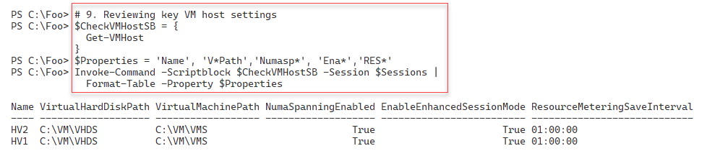

Figure 11.3: Viewing Hyper-V settings on HV1 and HV2

Insert image B42024_11_03.png

## There's more...

In step 1, you install the Hyper-V feature on two servers. You can only do this successfully if your host supports the necessary virtualization capabilities and you have enabled them in your system's BIOS. To ensure that your system supports Hyper-V, see this link: http://mikefrobbins.com/2012/09/06/use-powershell-to-check-for-processorcpu-second-level-address-translation-slat-support/. Additionally, ensure you double-check that you have enabled virtualization in the VM host's BIOS before running this step.

In step 2, you restart both servers. You could have allowed Install-WindowsFeature (used in step 1) to restart the servers automatically by using the -Restart switch. In automation terms, this could have meant that the system started rebooting before the remote script had been completed, which could cause Invoke-Command to error out. The recipe avoids this by not rebooting after installing the Hyper-V features. You then reboot the host in a controlled way in a later step. Once you complete the restart, your script can carry on managing the servers.

In steps 4through step 8, you set up one aspect of the VM hosts in each step. You could have combined these steps and just called Set-VMHost once with all Hyper-V server properties specified.

## See also

You can find more information on some of the Hyper-V features used in this recipe (details of which are outside the scope of this book) as follows:

|  |  |
| --- | --- |
| **Features** | **Links for more information** |
| Connecting to a VM, including enhanced session mode | https://docs.microsoft.com/windows-server/ virtualization/hyper-v/learn-more/use-local- resources-on-hyper-v-virtual-machine-with-vmconnect |
| Understanding the hard disk options | https://www.altaro.com/hyper-v/understanding- working-vhdx-files/ |
| Hyper-V and NUMA | https://blogs.technet.microsoft.com/ pracheta/2014/01/22/numa-understand-it-its- usefulness-with-windows-server-2012/ |
| Configuring Hyper-V Resource Metering | https://redmondmag.com/articles/2013/08/15/hyper-v-resource-metering.aspx |

# Creating a Hyper-V VM

Creating a Hyper-V VM is relatively straightforward and consists of simple steps. First, you need to create the VM itself inside your Hyper-V host. Then, you create the VM's virtual hard drive and add it to the VM. You may also wish to adjust the number of processors and memory for the VM and set the VM's DVD drive contents. Once you have created your VM, you need to install the VM's operating system (OS). You have numerous options for deploying Windows (or Linux) in a Hyper-V VM.

The Windows Assessment and Deployment Kit, a free product from Microsoft, contains various tools to assist in the automation of deploying Windows. These include Deployment Image Servicing and Management (DISM), Windows Imaging and Configuration Designer (Windows ICD), Windows System Image Manager (Windows SIM), User State Migration Tool (USMT), and a lot more. For more information on the tools and deploying Windows, see https://docs.microsoft.com/en-us/windows/deployment/windows-deployment-scenarios-and-tools.

Another way to install the OS into a VM is to create the VM (either with PowerShell or the Hyper-V Manager) and attach the OS's ISO image to the VM's DVD drive. After starting the VM, you do a manual installation, and once you complete the OS installation, you can use the recipes in this book to configure the server to your needs.

In this recipe, you create a VM, PSDirect. Initially, this has a VM name of PSDirect but a Windows-assigned hostname. In a later recipe, you change this hostname to Wolf. In building the VM, you assign the Windows Server 2022 DVD to the VM's DVD drive. This step ensures that Windows commences the GUI setup process when you start the VM. The result should be a fully installed OS inside the VM. The details of performing the actual installation are outside the scope of this recipe.

There are two minor issues with using the GUI to install Windows Server 2022. First, the Windows setup process randomly generates a machine name. Second, the VM is set up as a workgroup computer and not joined to the domain. You can easily script both renaming the server and joining the domain. The scripts used to generate the VM farm used in this book are examples of deploying Windows Server 2022 in a more automated fashion using a SETUP.XML file that specifies the installation's details. The scripts that create the VMs used are available online at GitHub. See https://github.com/doctordns/ReskitBuildScripts for the scripts and documentation on them.

## Getting ready

You run this recipe on the VM host HV1 you created in the Installing Hyper-V inside Windows Server. You also need the Windows Server ISO image. For testing purposes, this could be an evaluation version or a complete retail edition – and for this chapter, you could use an image of Windows Server 2022. To get an evaluation version of Windows Server, visit the Microsoft Evaluation Center at https://www.microsoft.com/evalcenter/evaluate-windows-server-2022.

You can also download an ISO of the latest preview copy of Windows Server and use ISO when installing the VM. See https://www.microsoft.com/en-us/software-download/windowsinsiderpreviewserver for preview build downloads, and https://techcommunity.microsoft.com/t5/windows-server-insiders/bd-p/WindowsServerInsiders for more information about Windows Insiders builds. For this, you need to be a member of the Windows Insiders program – membership is free. For more details on getting started with the Windows Insiders program, see https://docs.microsoft.com/windows-insider/get-started.

## How to do it...

1. Setting up the VM name and paths for this recipe

$VMName      = 'PSDirect'

$VMLocation  = 'C:\VM\VMS'

$VHDlocation = 'C:\VM\VHDS'

$VhdPath     = "$VHDlocation\PSDirect.Vhdx"

$ISOPath     = 'C:\Builds\en_windows_server_x64.iso'

If ( -not (Test-Path -Path $ISOPath -PathType Leaf)) {

  Throw "Windows Server ISO DOES NOT EXIST"

}

1. Creating a new VM

New-VM -Name $VMName -Path $VMLocation -MemoryStartupBytes 1GB

1. Creating a virtual disk file for the VM

New-VHD -Path $VhdPath -SizeBytes 128GB -Dynamic | Out-Null

1. Adding the virtual hard drive to the VM

Add-VMHardDiskDrive -VMName $VMName -Path $VhdPath

1. Setting ISO image in the VM's DVD drive

$IsoHT = @{

  VMName           = $VMName

  ControllerNumber = 1

  Path             = $ISOPath

}

Set-VMDvdDrive @IsoHT

1. Starting the VM

Start-VM -VMname $VMName

1. Viewing the VM

Get-VM -Name $VMName

## How it works...

In step 1, you specify VMs and VM hard drives' locations and assign them to variables. You also check to ensure that the Windows Server ISO is in the correct place with the correct name. Assuming the ISO exists and you have it named correctly, this step produces no output. If the step fails to find the file, it aborts with a suitable error message. Depending on which Windows Server 2022 ISO image you get, and from where the file name may vary. You can either change the file name on disk to match this step, or change the script

In step 2, you create a new VM using the New-VM cmdlet, with output that looks like this:

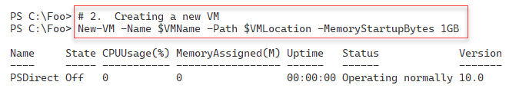

Figure 11.4: Creating a new VM

Insert image B42024_11_04.png

In step 3, you create a virtual disk file for the VM and add this VHDX to the PSDirect VM in step 4. In step 5, you add the ISO image to the PSDirect VM, and then, in step 6, you start the VM. These four steps create no output.

In the final step in this recipe, you use Get-VM to view the VM details, producing output like this:

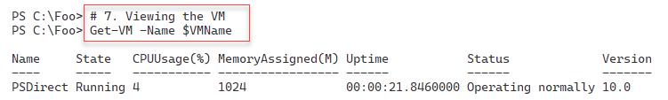

Figure 11.5: Viewing the new Hyper-V VM

Insert image B42024_11_05.png

## There's more...

In step 1, you specify the name of the ISO image for Windows Server 2022. Depending on which image you are using, the filename of the ISO you download may be different. Either adjust the filename to match this step or change it to match the ISO file's name. You can find ISO images for evaluation versions at the Microsoft Evaluation Center for released versions of Windows Server. If you like living in the fast lane, consider using a Windows Insiders preview build.

In step 2, you create a new VM. Although that step should succeed, you cannot run this VM yet, as you need to define at least one virtual hard drive to use with the VM. You carry out these configuration steps in subsequent steps.

Once you start the VM, in step 6, the VM runs and completes Windows Server's installation. To complete the installation of Windows Server, you need to use the GUI. For this chapter's purposes, accept all the installation defaults and ensure that you set the Administrator password to Pa$$w0rd. As with all the passwords used in this book, feel free to use whatever passwords you wish – but ensure that you don't forget them later.

# Using PowerShell Direct

PowerShell Direct is a Hyper-V feature that allows you to open PowerShell remoting sessions to a VM without a network connection. This feature enables you to create a PowerShell remoting session to a VM to fix issues, such as networking misconfiguration. You can't fix the issue without a working network connection to the VM, but until you fix the issue, you cannot make a connection to the VM. A “Catch-22” situation. With PS Direct, you can create a remoting session in the VM, as seen in this recipe.

## Getting ready

This recipe uses HV1, a Windows Server Datacenter host on which you have installed the Hyper-V feature. You should have also created a VM of Windows Server called PSDirect. This recipe demonstrates PowerShell Direct, so it doesn't matter which version of Windows Server you install so long as it is Windows Server 2016 or later (and you complete the installation of the OS inside the PSDirect VM).

You run the final steps of this recipe on DC1, showing how to connect to a VM remotely from the Hyper-V host.

## How to do it...

1. Creating a credential object for Reskit\Administrator

$Admin = 'Administrator'

$PS    = 'Pa$$w0rd'

$RKP   = ConvertTo-SecureString -String $PS -AsPlainText -Force

$Cred  = [System.Management.Automation.PSCredential]::New(

          $Admin, $RKP)

1. Viewing the PSDirect VM

Get-VM -Name PSDirect

1. Invoking a command on the VM specifying VM name

$CommandHT = @{

  VMName      = 'PSDirect'

  Credential  = $Cred

  ScriptBlock = {HOSTNAME.EXE}

}

Invoke-Command @CommandHT

1. Invoking a command based on VMID

$VMID = (Get-VM -VMName PSDirect).VMId.Guid

Invoke-Command -VMid $VMID -Credential $Cred  -ScriptBlock {ipconfig}

1. Entering a PS remoting session with the PSDirect VM

Enter-PSSession -VMName PSDirect -Credential $Cred

Get-CimInstance -Class Win32_ComputerSystem

Exit

Run the rest of this recipe from DC1.

1. Creating credential for PSDirect on DC1

$Admin = 'Administrator'

$PS    = 'Pa$$w0rd'

$RKP   = ConvertTo-SecureString -String $PS -AsPlainText -Force

$Cred  = [System.Management.Automation.PSCredential]::New(

          $Admin, $RKP)

1. Creating a remoting session to HV1 (Hyper-V Host)

$RemoteSession = New-PSSession -ComputerName HV1 -Credential $Cred

1. Entering an interactive session with HV1

Enter-PSSession $RemoteSession

1. Creating credential for PSDirect inside HV1

$Admin = 'Administrator'

$PS    = 'Pa$$w0rd'

$RKP   = ConvertTo-SecureString -String $PS -AsPlainText -Force

$Cred  = [System.Management.Automation.PSCredential]::New(

           $Admin, $RKP)

1. Entering and using the remoting session inside PSDirect

$PSDRS = New-PSSession -VMName PSDirect -Credential $Cred

Enter-PSSession -Session $PSDRS

HOSTNAME.EXE

1. Closing sessions

Exit-PSSession  # exits from session to PSDirect

Exit-PSSession  # exits from session to HV1

## How it works...

In step 1, you create a PowerShell credential object. You use this object later in this recipe to enable connection to the PSDirect VM. This step creates no output.

In step 2, you use the Get-VM cmdlet to view the PSDirect VM with output like this:

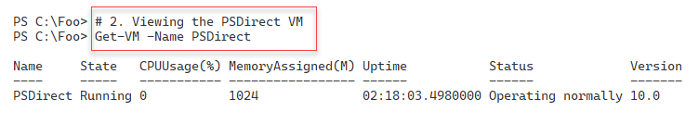

Figure 11.6: Viewing the PSDirect Hyper-V VM

Insert image B42024_11_06.png

In step 3, you use Invoke-Command to run the hostname command in the PSDirect VM, with output like this:

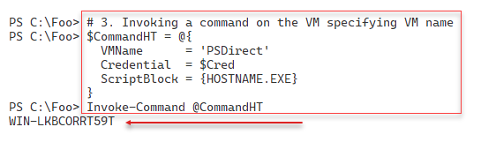

Figure 11.7: Checking the hostname of the PSDirect VM

Insert image B42024_11_07.png

In step 4, you invoke a command inside the PSDirect VM, but using the VM's GUID, with output like this:

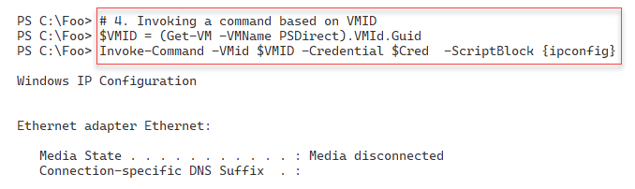

Figure 11.8: Checking the hostname of the PSDirect VM by VM GUID

Insert image B42024_11_08.png

In step 5, you use the Enter-PSSession command to enter an interactive session with the PSDirect VM. Inside the remoting session, you run Get-CimInstance to return details of the computer system of the VM. The output should look like this:

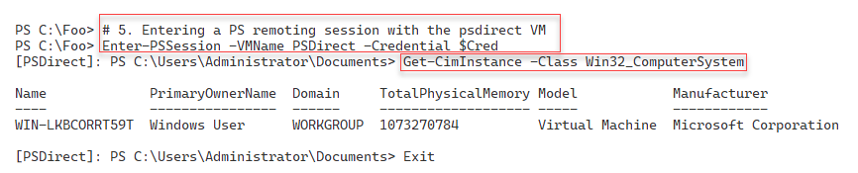

Figure 11.9: Entering a PS remoting session with the PSDirect VM

Insert image B42024_11_09.png

Now that you have created a working VM in HV1, you run the remainder of the VM setup steps remotely on DC1. In step 6, you create a credential object. In step 7, you use this credential object to create a PowerShell remoting session from DC1 to the Hyper-V Host (HV1). These two steps produce no console output.

In step 8, you enter a remoting session with HV1. Inside the remoting session (effectively on HV1), you create a PSDirect-based remoting session with the PSDirect VM, with output like this:

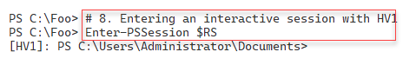

Figure 11.10: Using the remoting session on HV1

Insert image B42024_11_10.png

In step 9, you create a credential object for the PSDirect VM, creating no output. Then, in step 10, you enter the remote session to the PSDirect VM using the credential object and run the HOSTNAME.EXE command. The result of this step looks like this:

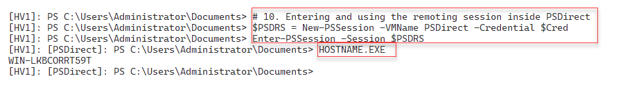

Figure 11.11: Running HOSTNAME.EXE in session to PSDirect from HV1

Insert image B42024_11_11.png

In the final step in this recipe, step 11, you exit from the interactive sessions on PSDirect and HV1 VMs. The output from this step looks like this:

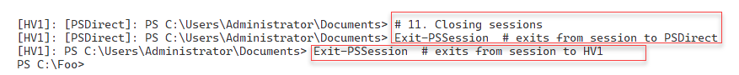

Figure 11.12: Exiting the remoting sessions

Insert image B42024_11_12.png

## There's more...

In *step 3*, you use PowerShell Direct to enter a VM session and run a command. Assuming you installed Windows in the PSDirect VM using a supported version of Windows, the setup process generates a random machine name. This machine name is different on each installation; therefore| the machine name of the host in your VM is certain to be different.

In *step 4*, you use the PowerShell Direct feature to run a command inside the PSDirect VM. As you can see from the output in Figure 12.8, the NIC for this VM is disconnected. Once inside this remote session, you can use the normal Windows Server troubleshooting tools to view and restore networking.

In *step 6*, you create and later use a credential object. Since HV1 is already domain-joined this is not strictly speaking necessary.

# Using Hyper-V VM groups

Hyper-Vs VM groups allow you to group VMs for automation. There are two types of VM groups you can create, VMCollectionType and ManagementCollectionType:

• A VMCollectionType VM group contains VMs.

• A ManagementCollectionType VM group contains VMCollectionType VM groups.

With VM groups, you might have two VMCollectionType VM groups, SQLAccVMG (which contains the SQLAcct1, SQLAcct2, and SQLAcct3 VMs), and a group, SQLMfgVMG, that contains the SQLMfg1 and SQLMfg2 VMs. You could create a ManagementCollectionType VM group, VM-All, containing the two VMCollectionType VM groups.

The VMGroup feature feels incomplete. For example, no -VMGroup parameters exist on any of the Hyper-V cmdlets. Thus you can’t easily execute any Hyper-V commands on all the members of a VM group. And having two types of groups seems confusing and possibly unhelpful. That said, the feature could be useful for large VM hosts running hundreds of VMs, if only from an organizational perspective.

## Getting ready

You run this recipe on the HV2, a Windows Server 2022 server with added Hyper-V feature. You configured this host in the Installing Hyper-V inside Windows Serverrecipe.

## How to do it...

1. Creating five VMs on

$VMLocation  = 'C:\Vm\VMs'   # Created in earlier recipe

# Create SQLAcct1

$VMN1        = 'SQLAcct1'

New-VM -Name $VMN1 -Path "$VMLocation\$VMN1"

# Create SQLAcct2

$VMN2        = 'SQLAcct2'

New-VM -Name $VMN2 -Path "$VMLocation\$VMN2"

 # Create SQLAcct3

$VMN3        = 'SQLAcct3'

New-VM -Name $VMN3 -Path "$VMLocation\$VMN3"

# Create SQLMfg1

$VMN4        = 'SQLMfg1'

New-VM -Name $VMN4 -Path "$VMLocation\$VMN4"

# Create SQLMfg2

$VMN5        = 'SQLMfg2'

New-VM -Name $VMN5 -Path "$VMLocation\$VMN5"

1. Viewing SQL VMs

Get-VM -Name SQL*

1. Creating Hyper-V VM groups

$VHGHT1 = @{

  Name      = 'SQLAccVMG'

  GroupType = 'VMCollectionType'

}

$VMGroupACC = New-VMGroup @VHGHT1

$VHGHT2 = @{

  Name      = 'SQLMfgVMG'

  GroupType = 'VMCollectionType'

}

$VMGroupMFG = New-VMGroup @VHGHT2

1. Displaying the VM groups on HV2

Get-VMGroup |

  Format-Table -Property Name, *Members, ComputerName

1. Creating arrays of group member VM names

$AccountingVMs   = 'SQLAcct1', 'SQLAcct2','SQLAcct3'

$ManfacturingVMs = 'SQLMfg1', 'SQLMfg2'

1. Adding members to the Accounting SQL VM group

Foreach ($Server in $AccountingVMs) {

    $VM = Get-VM -Name $Server

    Add-VMGroupMember -Name SQLAccVMG -VM $VM

}

1. Adding members to the Manufacturing SQL VM group

Foreach ($Server in $ManfacturingVMs) {

    $VM = Get-VM -Name $Server

    Add-VMGroupMember -Name SQLMfgVMG -VM $VM

}

1. Viewing VM groups on HV2

Get-VMGroup |

 Format-Table -Property Name, *Members, ComputerName

1. Creating a management collection VMG group

$VMGroupHT = @{

  Name      = 'VMMGSQL'

  GroupType = 'ManagementCollectionType'

}

$VMManufacturingSQL = New-VMGroup  @VMGroupHT

1. Adding the two VMCollectionType groups to the VMManagement group

Add-VMGroupMember -Name VMMGSQL -VMGroupMember $VMGroupACC,

                                               $VMGroupMFG

1. Setting FormatEnumerationLimit to 99

$FormatEnumerationLimit = 99

1. Viewing VM groups by type

Get-VMGroup | Sort-Object -Property GroupType |

  Format-Table -Property Name, GroupType, VMGroupMembers,

                         VMMembers

1. Stopping all the SQL VMs

Foreach ($VM in ((Get-VMGroup VMMGSQL).VMGroupMembers.vmmembers)) {

  Stop-VM -Name $VM.Name -WarningAction SilentlyContinue

}

1. Setting CPU count in all SQL VMs to 4

Foreach ($VM in ((Get-VMGroup VMMGSQL).VMGroupMembers.VMMembers)) {

  Set-VMProcessor -VMName $VM.name -Count 4

}

1. Setting Accounting SQL VMs to have 6 processors

Foreach ($VM in ((Get-VMGroup SQLAccVMG).VMMembers)) {

  Set-VMProcessor -VMName $VM.name -Count 6

}

1. Checking processor counts for all VMs sorted by CPU count

$VMS = (Get-VMGroup -Name VMMGSQL).VMGroupMembers.VMMembers

Get-VMProcessor -VMName $VMS.Name |

  Sort-Object -Property Count -Descending |

    Format-Table -Property VMName, Count

1. Remove VMs from VM groups

$VMs = (Get-VMGroup -Name SQLAccVMG).VMMEMBERS

Foreach ($VM in $VMS)  {

  $X = Get-VM -vmname $VM.name

  Remove-VMGroupMember -Name SQLAccVMG -VM $x

  }

$VMs = (Get-VMGroup -Name SQLMFGVMG).VMMEMBERS

Foreach ($VM in $VMS)  {

  $X = Get-VM -vmname $VM.name

  Remove-VMGroupMember -Name SQLmfgvMG -VM $x

}

1. Removing VMGrouwps from VMManagementGroups

$VMGS = (Get-VMGroup -Name VMMGSQL).VMMembers

Foreach ($VMG in $VMGS)  {

  $X = Get-VMGroup -vmname $VMG.name

  Remove-VMGroupMember -Name VMMGSQL -VMGroupName $x

}

1. Removing all the VMGroups

Remove-VMGroup -Name SQLACCVMG -Force

Remove-VMGroup -Name SQLMFGVMG -Force

Remove-VMGroup -Name VMMGSQL   -Force

## How it works...

In step 1, you create several VMs using the New-VM cmdlet, with the output of this step looking like this:

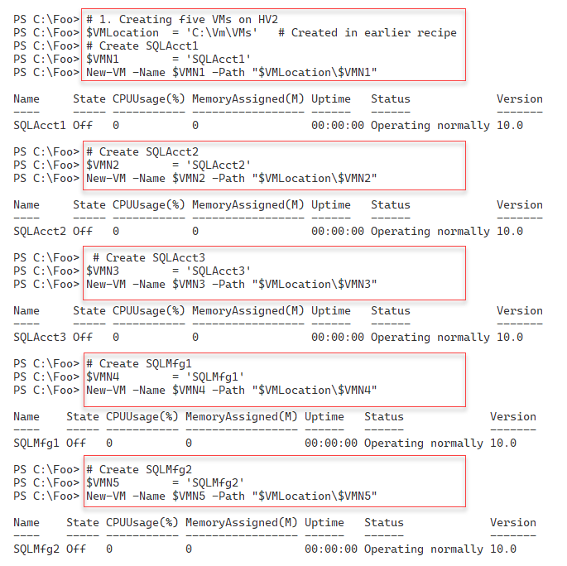

Figure 11.13: Creating new SQL VMs on HV2

Insert image B42024_11_13.png

In step 2, you use the Get-VM cmdlet to look at the five VMs you just created, with output like this:

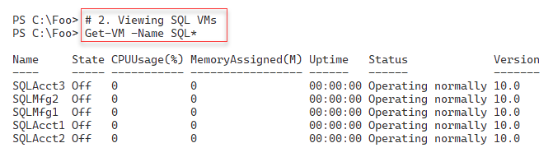

Figure 11.14: Viewing VMs on HV2

Insert image B42024_11_14.png

In step 3, you create several Hyper-V VM collection type VM groups, creating no output. In step 4, you examine the existing VM groups on HV2 with console output like this:

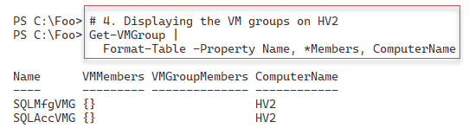

Figure 11.15: Viewing VM groups on HV2

Insert image B42024_11_15.png

To simplify VM collection groups' creation, in step 5, you create arrays of the VM names. In step 6, you add VMs to the SQLAccVMG VM group, while in step 7, you add VMs to the SQLMfgVMG VM group. These three steps produce no console output.

Then, in step 8, you view the VM groups again, with output like this:

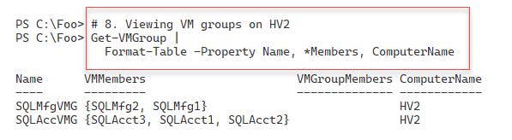

Figure 11.16: Viewing VM groups on HV2

Insert image B42024_11_16.png

In step 9, you create a VM management collection group, and in step 10, you populate the VM management collection. To simplify the output, in step 11, you set the $FormatEnumerationLimit to 99. These three steps create no console output.

In step 12, you view all the fully populated VM groups, sorted by VM group type, with output like this:

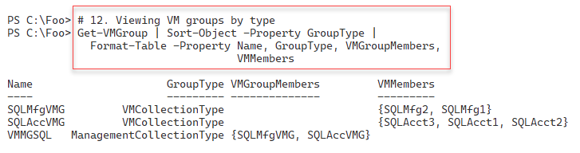

Figure 11.17: Viewing fully populated VM groups on HV2

Insert image B42024_11_17.png

In step 13, you use the VM groups you have created to stop all the SQL VMs. In step 14, you set the VMs in the VMMGSQL VM management collection group to have four virtual processors, and in step 15, you set the VMs in the SQLAccVMG VM collection group to each have six virtual processors. These three steps produce no output to the console.

In step 16, you review the virtual processors assigned to each SQL VM like this:

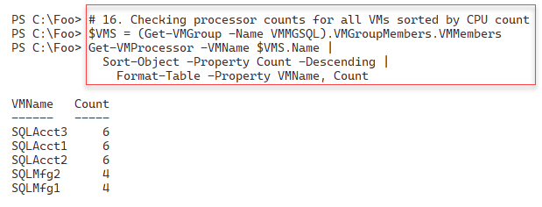

Figure 11.18: Viewing Processor counts for VMs on HV2

Insert image B42024_11_18.png

In step 17, you remove all the VMs from the VM collection groups, and in step 18, you remove all the members from the VM management VM groups. Finally, in step 19, you remove all the VM groups. These three steps produce no output.

## There's more...

In step 11, you set a value for the $FormatEnumerationLimit automatic variable. This variable controls how many repeating groups the Format-* cmdlets display. By default, PowerShell initializes this variable with a value of 4 . Using this default, in step 11, you would see at most four members of each of the VM groups, with PowerShell displaying "…" to indicate that you have more than four members. If you set $FormatEnumerationLImit to 0 (zero), PowerShell displays all members irrespective of the number. With this step, PowerShell can display up to 99 VM members for each VM group. You may wish to set this preference variable in your profile or inside specific scripts in production.

In this recipe, you used five supposed SQL server VMs to illustrate the use of VM groups. There are no actual usable VMs (each of the five VMs you create does not have an OS or SQL server loaded). You could, should you wish, add steps to install Windows Server and SQL Server on these VMs.

VM groups provide few benefits for most Hyper-V customers, and as mentioned, VM Groups feel half-implemented. In production, you could easily create string variables holding VM names and use these instead of VM groups.

# Configuring VM Hardware

Configuring hardware in your VM is like configuring a physical computer without needing a screwdriver. With a physical computer, you can adjust the CPUs and BIOS settings and change physical RAM, network interfaces, disk interfaces, disk devices, DVD drives (with/without a loaded DVD), and more. You can find each of these virtual components within a Hyper-V VM. As you can see in the recipe, the PowerShell cmdlets make it simple to configure the virtual hardware available to any Hyper-V VM.

In this recipe, you adjust the VM's BIOS, CPU count, and memory and then add a SCSI controller. With the controller in place, you create a new virtual disk and assign it to the SCSI controller. Then, you view the results.

Like most physical servers, you cannot change all of these virtual hardware components while your virtual server is up and running. You run this recipe from HV1 and turn the PSDirect VM off before configuring the virtual hardware.

This recipe does not cover the VM's virtual NIC. By default, VMs (such as those created in the Creating a Hyper-V VM recipe) contain a single virtual NIC. You can add additional NICs to any VM should you wish to. You configure VM networking in the Configuring VM networking recipe later in this chapter.

## Getting ready

This recipe uses HV1, a Windows Server 2022 host on which you have installed the Hyper-V feature. You should also have created a VM of Windows Server called PSDirect.

## How to do it...

1. Turning off the PSDirect VM

Stop-VM -VMName PSDirect

Get-VM -VMName PSDirect

1. Setting the start-up order in the VM's BIOS

$Order = 'IDE','CD','LegacyNetworkAdapter','Floppy'

Set-VMBios -VmName PSDirect -StartupOrder $Order

Get-VMBios PSDirect

1. Setting and viewing CPU count for PSDirect

Set-VMProcessor -VMName PSDirect -Count 2

Get-VMProcessor -VMName PSDirect |

  Format-Table VMName, Count

1. Setting and viewing PSDirect memory

$VMConfigurationHT = [ordered] @{

  VMName               = 'PSDirect'

  DynamicMemoryEnabled = $true

  MinimumBytes         = 512MB

  StartupBytes         = 1GB

  MaximumBytes         = 2GB

}

Set-VMMemory @VMConfigurationHT

Get-VMMemory -VMName PSDirect

1. Adding and viewing a ScsiCon troller in the PSDirect VM

Add-VMScsiController -VMName PSDirect

Get-VMScsiController -VMName PSDirect

1. Starting the PSDirect VM

Start-VM -VMName PSDirect

Wait-VM  -VMName PSDirect -For IPAddress

1. Creating a new VHDX file for the PSDirect VM

$VHDPath = 'C:\VM\VHDs\PSDirect-D.VHDX'

New-VHD -Path $VHDPath -SizeBytes 8GB -Dynamic

1. Getting Controller number of the newly added SCSI controller

$VM            = Get-VM -VMName PSDirect

$SCSIController = Get-VMScsiController -VM $VM |

                    Select-Object -Last 1

1. Adding the VHD to the ScsiController

$VMNewDiskHT = @{

    VMName            = 'PSDirect'

    ControllerType    = $SCSIController.ControllerNumber

    ControllerNumber  =  0

    ControllerLocation = 0

    Path               = $VHDPath

}

Add-VMHardDiskDrive @VMNewDiskHT

1. Viewing drives in the PSDirect VM

Get-VMScsiController -VMName PSDirect |

  Select-Object -ExpandProperty Drives

## How it works...

In step 1, you turn off the PSDirect VM and check the status of the VM, with output like this:

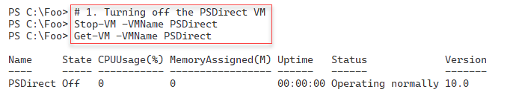

Figure 11.19: Stopping the PSDirect VM

Insert image B42024_11_19.png

In step 2, you set the start-up order for the VM’s BIOS. Then you view the BIOS details. The output of this step is:

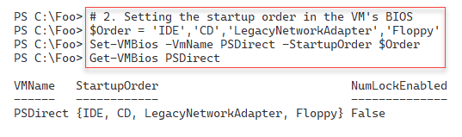

Figure 11.20: Updating and viewing the VM's BIOS

Insert image B42024_11_20.png

In step 3, you adjust and then view the number of virtual processors for the PSDirect VM, with output like this:

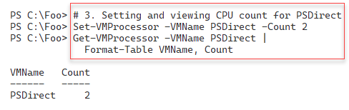

Figure 11.21: Updating and viewing the VM's BIOS

Insert image B42024_11_21.png

In step 4, you set the virtual memory for the PSDirect VM and then view the memory settings with the following output:

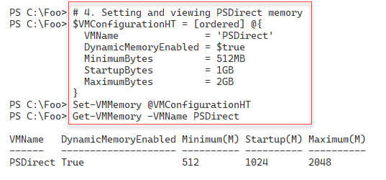

Figure 11.22: Changing and viewing VM memory

Insert image B42024_11_22.png

In step 5, you add a second SCSI controller to the PSDirect VM. You then view the SCSI controllers inside the PSDirect VM. You should see output like this:

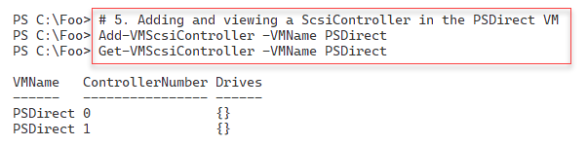

Figure 11.23: Adding and viewing virtual disk controllers

Insert image B42024_11_23.png SCSI

Now that you have adjusted the virtual hardware for the PSDirect VM, in step 6, you restart the VM and wait for the VM to come up. This step generates no output.

In step 7, you create a new virtual disk file for the PSDirect VM, with output like this:

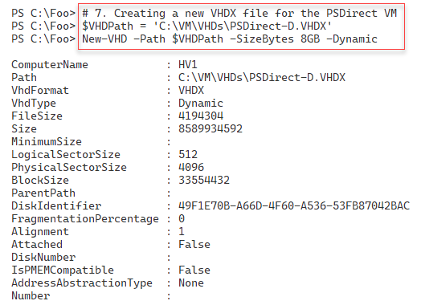

Figure 11.24: Creating a new virtual disk drive

Insert image B42024_11_24.png SCSI

In step 8, you get the SCSI controllers in the PSDirect VM and the controller you added in step 5. Then, in step 9, you add the newly created virtual disk drive to the recently added SCSI controller. These two steps produce no console output.

In step 10, you get the disk drives attached to SCSI controllers in the PSDirect VM, with output like this:

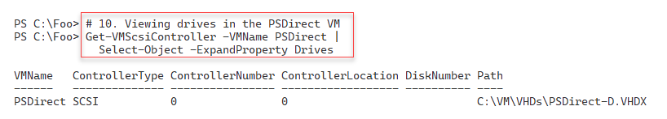

Figure 11.25: Viewing the SCSI disk drives in the PSDirect VM

Insert image B42024_11_25.png SCSI

## There's more...

With Hyper-V, you can only update some VM hardware configuration settings when you have turned off the VM. In step 1, you switch the VM off to enable you to make virtual BIOS settings. Once you have completed these BIOS (and possibly other) changes, you can restart the VM.

In step 2, you set the start-up order for the VM and view the settings. In production, you may have scripts like this that set VM settings to a preferred corporate standard, irrespective of the default values.

In step 3, you set the number of processors in the nested VM to 2. You should ensure that the Hyper-V host has at least two virtual CPUs if not more.

Some settings, such as SCSI disk controllers and disk drives, can be added and removed from a running VM. In step 9, you add a newly created virtual disk drive to the running PSDirect VM.

In step 10, you view the SCSI disks in the PSDirect VM. This VM has an IDE-based boot disk. Hence you see a single disk in the output of this step.

# Configuring VM Networking

In the Creating a Hyper-V VM recipe, you created a VM, PSDirect. This VM has, by default, a single network card that Hyper-V sets to acquire IP address details from DHCP. In this recipe, you create a new switch, assign the VM#s NIC to a switch, and configure IP address details for the virtual network adapter.

## Getting ready

You run this recipe on HV1, which uses the PSDirect VM you created in the Creating a Hyper-V VM recipe. This recipe also makes use of a DHCP server running on DC1. In Chapter 5, Managing Networking in the Enterprise, you set the DHCP service up in the Installing DHCP recipe. Then, configure the DHCP server in the Configuring DHCP scopes and options recipe.

This chapter uses the PSDirect VM you created earlier. When you build this machine using the normal setup routine, Windows assigns a random machine name, which you saw in a previous recipe (Using PowerShell Direct). In this recipe, you also change the name of the host inside to Wolf.

In this recipe, you set the PSDirect VM's networking card to enable MAC address spoofing. This step lets the VM see the network and get an IP address from the DHCP server on DC1. If you are running HV1 as a VM, you must also enable MAC spoofing on the NIC(s) in this VM on the VM host of HV1.

## How to do it...

1. Setting the PSDirect VM's NIC

Get-VM PSDirect |

  Set-VMNetworkAdapter -MacAddressSpoofing On

1. Getting NIC details and any IP addresses from the PSDirect VM

Get-VMNetworkAdapter -VMName PSDirect

1. Creating a credential then getting VM networking details

$Administrator = 'localhost\Administrator'

$Password      = 'Pa$$w0rd'

$RKPassword =

  ConvertTo-SecureString -String $Password -AsPlainText -Force

$RKCred     = [System.Management.Automation.PSCredential]::new(

                                            $Administrator,

                                            $RKPassword)

$VMHT = @{

    VMName      = 'PSDirect'

    ScriptBlock = {ipconfig}

    Credential  = $RKCred

}

Invoke-Command @VMHT

1. Creating a new virtual switch on HV1

$VirtSwitchHT = @{

    Name           = 'Internal'

    NetAdapterName = 'Ethernet'

    Notes          = 'Created on HV1'

}

New-VMSwitch @VirtSwitchHT

1. Connecting the PSDirect VM's NIC to the Internal switch

Connect-VMNetworkAdapter -VMName PSDirect -SwitchName Internal

1. Viewing VM networking information

Get-VMNetworkAdapter -VMName PSDirect

1. Observing the IP address in the PSDirect VM

$CommandHT = @{

    VMName      = 'PSDirect'

    ScriptBlock = {ipconfig}

    Credential  = $RKCred

}

Invoke-Command @CommandHT

1. Viewing the hostname on PSDirect

$CommandHT.ScriptBlock = {hostname}

Invoke-Command @CommandHT

1. Changing the name of the host in the PSDirect VM

$CommandHT.ScriptBlock = {Rename-Computer -NewName Wolf -Force}

Invoke-Command @CommandHT

1. Rebooting and wait for the restarted PSDirect VM

Restart-VM -VMName PSDirect -Wait -For IPAddress -Force

1. Getting hostname of the PSDirect VM

$CommandHT.ScriptBlock = {HOSTNAME}

Invoke-Command @CommandHT

## How it works...

In step 1, you set the PSDirect VM's NIC to enable MAC address spoofing. There is no output from this step.

In step 2, you get the NIC details for the NIC assigned to the PSDirect VM, with output like this:

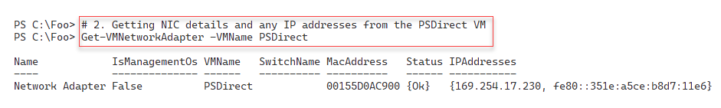

Figure 11.26: Viewing the NIC details for the PSDirect VM

Insert image B42024_11_26.png

In step 3, you create a credential object for the PSDirect VM. Then you use that credential to run the ipconfig.exe command from inside the VM, with output like this:

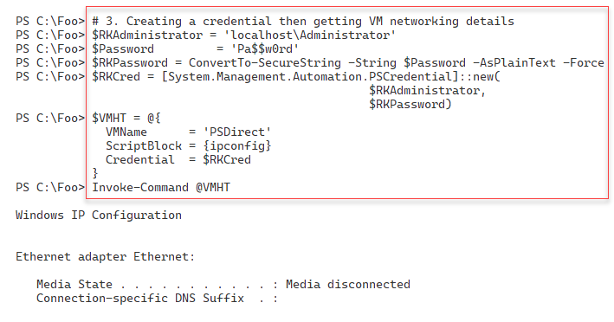

Figure 11.27: Viewing the IP configuration inside the PSDirect VM

Insert image B42024_11_27.png

In step 4, you create a new Hyper-V VM switch inside the HV1 VM host, which produces the following output:

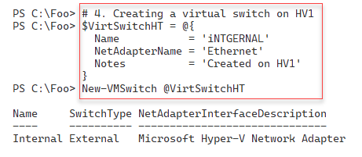

Figure 11.28: Creating a new virtual switch inside HV1 VM

Insert image B42024_11_28.png

In step 5, you connect the NIC in the PSDirect VM to the VM switch, creating no output. In step 6, you can review the networking information for the PSDirect VM with output like this:

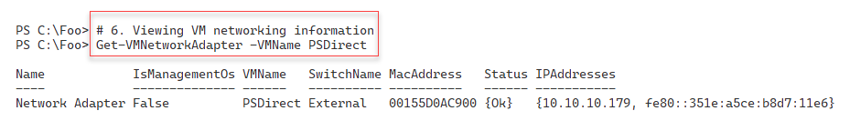

Figure 11.29: Viewing the PSDirect NIC settings

Insert image B42024_11_29.png

In step 7, you execute a script block inside the PSDirect VM to return the VM's network details, which produces output that looks like this:

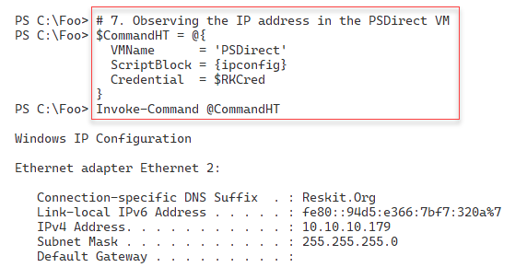

Figure 11.30: Observing the PSDirect network settings

Insert image B42024_11_30.png

In step 8, you view the existing hostname of the PSDirect VM with output that looks like this:

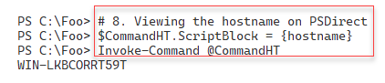

Figure 11.31: Viewing the hostname of the PSDirect VM

Insert image B42024_11_31.png

In step 9, you use the Rename-Computer cmdlet, running inside the PSDirect VM. This step changes the hostname of the VM to Wolf and produces the following output:

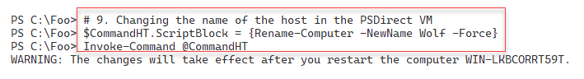

Figure 11.32: Changing the VM’s hostname

Insert image B42024_11_32.png

In step 10, you reboot the PSDirect VM, generating no console output. After the VM has restarted, in step 11, you run the HOSTNAME command inside the VM, with console output like this:

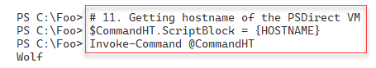

Figure 11.33: Viewing the updated hostname in the PSDirect VM

Insert image B42024_11_33.png

## There's more...

In step 1, you set the PSDirect VM's NIC to enable MAC address spoofing. You can read more about MAC address spoofing with Hyper-V at https://charbelnemnom.com/how-to-set-dynamic-mac-address-on-a-hyper-v-vm-with-powershell/.

In step 5, you connect the PSDirect VM's NIC to the virtual switch you created on HV1. Since the PSDirect VM's NIC is (by default) set to get IP addresses via DHCP, as soon as you connect the virtual NIC to the switch, the VM should acquire IP address configuration from the DC1 host, which is running DHCP. You see the DHCP-acquired IP configuration details in the output from step 6.

# Implementing nested virtualization

Nested virtualization is a feature that enables a Hyper-V VM to host VMs that also have virtualization enabled. You could, for example, take a Hyper-V host (say, HV1) and, on that host, run a VM (say, PSDirect). With nested virtualization, you could enable your PSDirect VM to host VMs. You could then create a nested VM inside the PSDirect VM called NestedVM.

Nested VMs have many uses. First, nested virtual machines hosted in one VM are provided hardware isolation from nested VMs run in other VMs. In this case, nested virtualization offers additional security for VMs.

Nested virtualization is also helpful for testing and education/training. You could give students a single VM (on a large blade server, for example). Nested virtualization enables them to create additional VMs for the course lab work. And most IT pros find it cool! You can, for example, run all the recipes in this chapter using nested virtualization.

Enabling nested Hyper-V is very simple. First, you must update the virtual CPU in the VM you want to support nesting. Therefore, you adjust the virtual CPU in the PSDirect VM to expose the virtualization extensions in this recipe. Changing the BIOS to do this must be done after you turn off the VM. After you restart the VM, you install the Hyper-V feature and create the NestedVM nested VM. This recipe does not show the details of configuring the NestedVM VM. To expose the virtualisation extensions for any Hyper-V VM, you use the Set‑VMProcessor -ExposeVirtualizationExtensions $True, and specifyiung a VM name

## Getting ready

This recipe uses the HV1 Hyper-V host, with an existing Hyper-V VM, PSDirect, available. The recipe assumes that you have set up PSDirect, as discussed in the Creating a Hyper-V VM recipe earlier in this chapter.

## How to do it...

1. Stopping the PSDirect VM

Stop-VM -VMName PSDirect

1. Setting the VM's processor to support virtualization

$VMHT = @{

  VMName                         = 'PSDirect'

  ExposeVirtualizationExtensions = $true

}

Set-VMProcessor @VMHT

Get-VMProcessor -VMName PSDirect |

  Format-Table -Property Name, Count,

                         ExposeVirtualizationExtensions

1. Starting the PSDirect VM

Start-VM -VMName PSDirect

Wait-VM  -VMName PSDirect -For Heartbeat

Get-VM   -VMName PSDirect

1. Creating credentials for PSDirect

$User = 'Wolf\Administrator'

$PasswordHT = @{

  String      = 'Pa$$w0rd'

  AsPlainText = $true

  Force       = $true

}

$SecurePW  = ConvertTo-SecureString @PasswordHT

$Cred = [System.Management.Automation.PSCredential]::new(

                                               $User, $SecurePW)

1. Creating a script block for remote execution

$ScriptBlock = {

  Install-WindowsFeature -Name Hyper-V -IncludeManagementTools

}

1. Creating a remoting session to PSDirect

$Session = New-PSSession -VMName PSDirect -Credential $Cred

1. Installing Hyper-V inside PSDirect

$InstallHT = @{

  Session     = $Session

  ScriptBlock = $ScriptBlock

}

Invoke-Command @InstallHT

1. Restarting the VM to finish adding Hyper-V to PSDirect

Stop-VM  -VMName PSDirect

Start-VM -VMName PSDirect

Wait-VM  -VMName PSDirect -For IPAddress

Get-VM   -VMName PSDirect

1. Creating a nested VM inside the PSDirect VM

$ScriptBlock2 = {

        $VMName = 'NestedVM'

        New-VM -Name $VMName -MemoryStartupBytes 1GB | Out-Null

        Get-VM

}

$InstallHT2 = @{

  VMName = 'PSDirect'

  ScriptBlock = $ScriptBlock2

}

Invoke-Command @InstallHT2 -Credential $Cred

## How it works...

In step 1, you ensure that the PSDirect VM has stopped. This step creates no console output. In step 2, you configure the VM's virtual processor to support virtualization. Then you review the VM’s processor settings, which look like this:

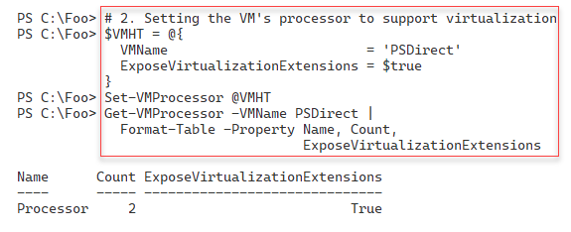

Figure 11.34: Viewing the virtual processor inside PSDirect

Insert image B42024_11_34.png

In step 3, you start the PSDirect VM and then use Get-VM to view details about the VM, which looks like this:

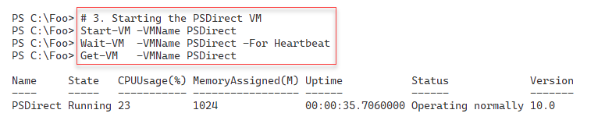

Figure 11.35: Starting and viewing PSDirect

Insert image B42024_11_35.png

In step 4, you create a PowerShell credential object for the PSDirect VM. In step 5, you create a script block that installs the Hyper-V feature. Then in step 6, you create a PowerShell remoting session with the PSDirect VM. These three steps produce no output to the console.

In step 7, you use the remoting session to install the Hyper-V feature inside the PSDirect VM, producing output like this:

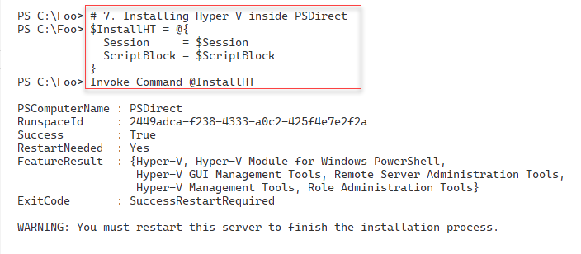

Figure 11.36: Installing Hyper-V inside the PSDirect VM

Insert image B42024_11_36.png

As you can see from the output, after installing the Hyper-V feature inside PSDirect, you need to reboot the VM to complete the installation process. In step 8, you restart PSDirect, wait for it to start, and finally view the VM details with output like this:

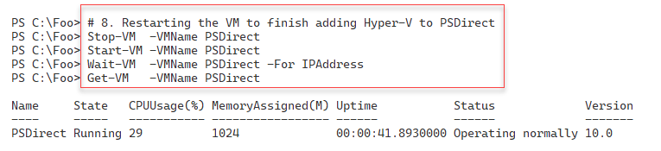

Figure 11.37: Restarting the PSDirect VM

Insert image B42024_11_37.png

In the final step in this recipe, step 9, you create a new nested VM, NestedVM, inside the PSDirect VM, which produces console output like this:

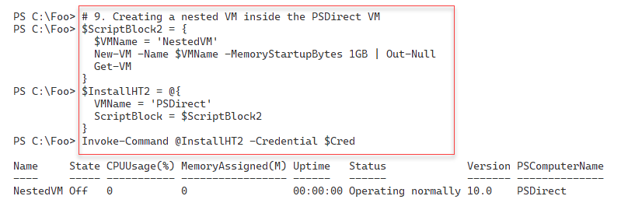

Figure 11.38: Creating a nested VM inside PSDirect

Insert image B42024_11_38.png

## There's more...

In step 7, you install the Hyper-V feature in the nested VM (NestedVM) inside the PSDirect VM. The installation of Hyper-V inside the PSDirect VM is successful, as you can see in this step's output. Had the PSDirect VM not supported virtualization, the Install-WindowsFeature cmdlet would have thrown an error. Likewise, had you not installed Hyper-V in PSDirect, step 9 would have failed without creating the VM. If you choose, you can adjust the Creating a Hyper-V VM recipe steps to install and configure an OS in the NestedVM.

# Managing VM State

Hyper-V allows you to start, stop, and pause a Hyper-V VM. You can also save the VM and its state and then restore the VM. You use the Hyper-V cmdlets to manage your VMs locally (on the Hyper-V host in a remote desktop (RDP) or PowerShell remoting session) or use RSAT tools to manage the state of VMs on remote Hyper-V hosts.

You can start and stop VMs either directly or via the task scheduler. You might want to start up a few VMs every working morning and stop them each evening. If you have provisioned your Hyper-V host with spinning disks, starting multiple VMs at once stresses the storage subsystem, especially if you are using any form of RAID on the disk drives you use to hold your virtual disks. Depending on your hardware, you can sometimes hear the IO Blender effect starting up a small VM farm. Even with solid-state disks, starting several VMs simultaneously puts a considerable load on the Windows storage system. In such cases, you might pause a VM and let others start faster.

Saving a VM can help avoid a long start-up process. If you have created multiple VMs to test the recipes in this book, you might save VMs and restart them as you move through the chapters.

## Getting ready

You run this recipe on the HV1 host after you have created the PSDirect VM. You created that VM in the Creating a Hyper-V VM recipe.

## How to do it...

1. Getting the VM's state to check if it is off

Stop-VM -Name PSDirect -WarningAction SilentlyContinue

Get-VM -Name PSDirect

1. Starting the VM

Start-VM -VMName PSDirect

Wait-VM -VMName PSDirect -For IPAddress

Get-VM -VMName PSDirect

1. Suspending and viewing the PSDirect VM

Suspend-VM -VMName PSDirect

Get-VM -VMName PSDirect

1. Resuming the PSDirect VM

Resume-VM -VMName PSDirect

Get-VM -VMName PSDirect

1. Saving the VM

Save-VM -VMName PSDirect

Get-VM -VMName PSDirect

1. Resuming the saved VM and viewing the status

Start-VM -VMName PSDirect

Get-VM -VMName PSDirect

1. Restarting the PSDirect VM

Restart-VM -VMName PSDirect -Force

Get-VM     -VMName PSDirect

1. Waiting for the PSDirect VM to get an IP address

Wait-VM    -VMName PSDirect -For IPaddress

Get-VM     -VMName PSDirect

1. Performing a hard power off on the PSDirect VM

Stop-VM -VMName PSDirect -TurnOff

Get-VM  -VMname PSDirect

## How it works...

In step 1, you stop the PSDirect VM and check its status. The output looks like this:

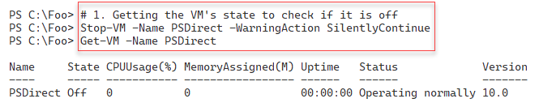

Figure 11.39: Stopping the PSDirect VM

Insert image B42024_11_39.png

In step 2, you use the Start-VM cmdlet to start the PSDirect VM and then use Wait-VM to wait for the VM to start up and get an IP address. The output from this step looks like this:

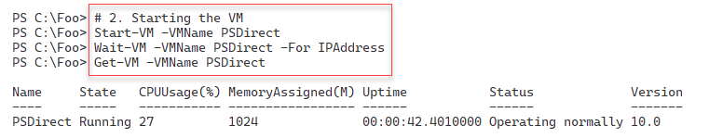

Figure 11.40: Starting the PSDirect VM

Insert image B42024_11_40.png

In step 3, you use Suspend-VM to pause the PSDirect VM and observe its status with the following output:

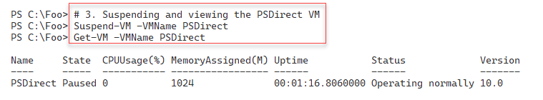

Figure 11.41: Suspending the PSDirect VM

Insert image B42024_11_41.png

Having paused the PSDirect VM, in step 4, you use the Resume-VM cmdlet to unpause the VM with the following output:



Figure 11.42: Resuming the PSDirect VM

Insert image B42024_11_42.png

In step 5, you save the PSDirect VM, with output like this:

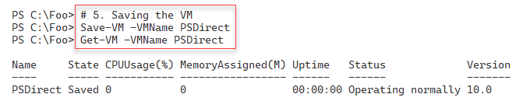

Figure 11.43: Saving the PSDirect VM

Insert image B42024_11_43.png

You can resume a saved VM by using the Start-VM command, as you see in step 6, which creates output like this:

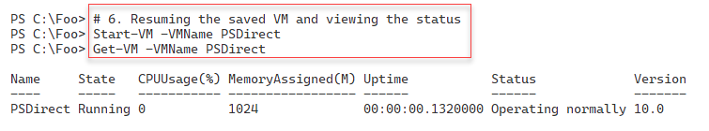

Figure 11.44: Resuming the PSDirect VM (after you have saved it)

Insert image B42024_11_44.png

Step 7 demonstrates using the Restart-VM cmdlet to restart the PSDirect VM. The output from this step looks like this:

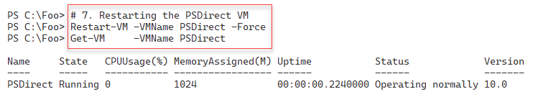

Figure 11.45: Restarting the PSDirect VM (after you have saved it)

Insert image B42024_11_45.png

In the previous step, you restarted the VM, which can take some time, depending on your VM host and VM size. In step 8, you use the Wait-VM cmdlet to wait for the VM to restart and then use the Get-VM cmdlet to observe the status of the PSDirect VM like this:

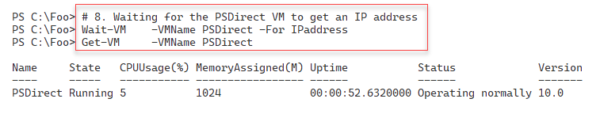

Figure 11.46: Waiting for the PSDirect VM to restart

Insert image B42024_11_46.png

In the final step in this recipe, step 9, you perform a hard power off of the PSDirect VM, with output like this:

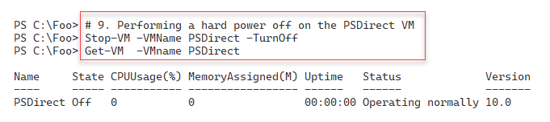

Figure 11.47: Turning off the PSDirect VM

Insert image B42024_11_47.png

## There's more...

Managing the state of VMs is straightforward with the cmdlets in the Hyper-V module. You can start and stop a VM just like with physical machines. The Hyper-V cmdlets allow you to start a VM on a Hyper-V

host and wait until it is far enough in the start-up process to enable you to interact with the VM. This is an important feature of automation.

In some scenarios, saving a VM is very useful. If you have VMs that you use infrequently, you can save them rather than shutting them down, thereby improving the VM start-up time. You might also save all the VMs when you need to reboot the VM host.

One thing to be aware of, if your VM host updates itself via Windows Update or WSUS, you may find from time to time that Windows can not restart a saved VM. You can remove the saved state and restart.

# Managing VM and VM Storage Movement

Hyper-V enables you to move a VM to a new VM host and move a VM's storage to a new location. Moving a VM and moving a VM's storage are two important features you can use to manage your Hyper-V hosts.

Hyper-V’s Live migration feature allows you to move a Hyper-V VM to a different VM host without downtime. You can also move a VM's storage (any VHD/VHDX associated with the VM) to a different location. You can combine these and move a VM supported by local storage to another Hyper-V host, moving both the VM and the underlying storage. Storage migration works best when the VM is held on shared storage (via a fiber channel SAN, iSCSI, or SMB).

In this recipe, you first move the storage for the PSDirect VM. You created this VM in the Creating a Hyper-V VM recipe and stored the VM configuration and the VM's VHD on the H: drive. To move the storage, you create a new SMB share and then move the VM's storage to the new SMB share.

In the second part of this recipe, you do a live migration of the PSDirect VM from HV1 to HV2. This VM movement is known as live migration because you are migrating a live VM that stays up and running during migration.

## Getting ready

In this recipe, you use the HV1 and HV2 systems (Windows 2022 Server with Hyper-V loaded) as set up in the Installing Hyper-V inside Windows Server recipe, and the PSDirect VM created in the Creating a Hyper-V VM recipe.

In the first part of this recipe, you move the storage for the PSDirect VM. You created this VM in the Creating a Hyper-V VM recipe. You should ensure that this VM is up and running.

You run the first part of this recipe on HV1 to move the PSDirect VM from HV1 to HV2. Once you have moved the VM to HV2, you run the final part of this recipe on HV2 to move the VM back to HV1. If you attempted to run the last part of this recipe remotely, for example, for a client machine or from HV1 (suitably wrapped up in a script block you run with Invoke-Command), you would see a Kerberos error due to the Kerberos double hop problem. You could have deployed Windows Credential Security System Provider (CredSSP) to overcome that issue.

## How to do it...

1. Viewing the PSDirect VM on HV1 and verifying that it is turned on and running

Start-VM -VMName PSDirect

Get-VM -Name PSDirect -Computer HV1

1. Getting the VM configuration location

(Get-VM -Name PSDirect).ConfigurationLocation

1. Getting the virtual hard drive locations

Get-VMHardDiskDrive -VMName PSDirect |

  Format-Table -Property VMName, ControllerType, Path

1. Moving the VMs to the C:\PSDirectNew folder

$MoveStorageHT = @{

  Name                   = 'PSDirect'

  DestinationStoragePath = 'C:\PSDirectNew'

}

Move-VMStorage @MoveStorageHT

1. Viewing the configuration details after moving the VM's storage

(Get-VM -Name PSDirect).ConfigurationLocation

Get-VMHardDiskDrive -VMName PSDirect |

  Format-Table -Property VMName, ControllerType, Path

1. Getting the VM details for VMs from HV2

Get-VM -ComputerName HV2

1. Creating Internal virtual switch on HV2

$ScriptBlock = {

  $NSHT = @{

    Name           = 'Internal'

    NetAdapterName = 'Ethernet'

    ALLOWmAnagementOS = $true

  }

  New-VMSwitch @NSHT

}

Invoke-Command -ScriptBlock $ScriptBlock -ComputerName HV2

1. Enabling VM migration from both HV1 and HV2

Enable-VMMigration -ComputerName HV1, HV2

1. Configuring VM Migration on both hosts

$MigrationHT = @{

  UseAnyNetworkForMigration                 = $true

  ComputerName                              = 'HV1', 'HV2'

  VirtualMachineMigrationAuthenticationType =  'Kerberos'

  VirtualMachineMigrationPerformanceOption  = 'Compression'

}

Set-VMHost @MigrationHT

1. Moving the PSDirect VM to HV2

$Start = Get-Date

$VMMoveHT = @{

  Name                   = 'PSDirect'

  ComputerName           = 'HV1'

  DestinationHost        = 'HV2'

  IncludeStorage         =  $true

  DestinationStoragePath = 'C:\PSDirect' # on HV2

}

Move-VM @VMMoveHT

$Finish = Get-Date

1. Displaying the time taken to migrate

$OS = "Migration took: [{0:n2}] minutes"

($OS -f ($($Finish-$Start).TotalMinutes))

1. Checking the VMs on HV1

Get-VM -ComputerName HV1

1. Checking the VMs on HV2

Get-VM -ComputerName HV2

1. Looking at the details of the PSDirect VM on HV2

((Get-VM -Name PSDirect -Computer HV2).ConfigurationLocation)

Get-VMHardDiskDrive -VMName PSDirect -Computer HV2  |

  Format-Table -Property VMName, Path

Run the remainder of this recpie on HV2.

1. Moving the PSDirect VM back to HV1

$Start2 = Get-Date

$VMHT2  = @{

    Name                   = 'PSDirect'

    ComputerName           = 'HV2'

    DestinationHost        = 'HV1'

    IncludeStorage         =  $true

    DestinationStoragePath = 'C:\vm\vhds\PSDirect' # on HV1

}

Move-VM @VMHT2

$Finish2  = Get-Date

1. Displaying the time taken to migrate back to HV1

$OS = "Migration back to HV1 took: [{0:n2}] minutes"

($OS -f ($($fINISH2 - $Start2).TotalMinutes))

1. Check VMs on HV1

Get-VM -Computer HV1

## How it works...

In step 1, you check the status of the PSDirect VM to confirm that it is up and running. The output should look like this:

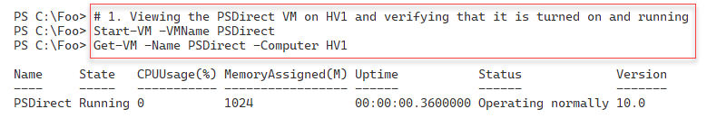

Figure 11.48: Checking the status of the PSDirect VM

Insert image B42024_11_48.png

In step 2, you determine the location that Hyper-V is using to store the VM configuration for the PSDirect VM, with console output like this:

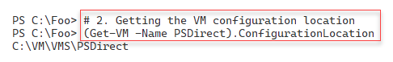

Figure 11.49: Checking the PSDirect VM configuration location

Insert image B42024_11_49.png

In step 3, you view the locations that Hyper-V is using to store the virtual hard disks for the PSDirect VM, with output like this:

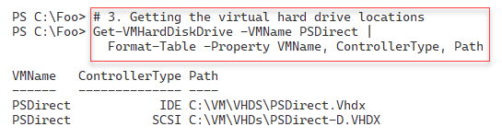

Figure 11.50: Viewing PSDirect's virtual hard drives

Insert image B42024_11_50.png

In step 4, you move the storage of the running PSDirect VM. This step generates no output. After moving the VM's storage, in step 5, you review the VM configuration location and the details of the hard drives for the PSDirect VM. The output of this step looks like this:

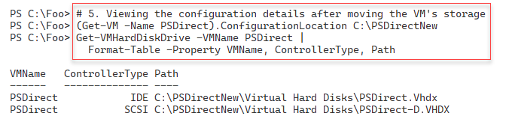

Figure 11.51: Viewing PSDirect's virtual hard drives after moving storage

Insert image B42024_11_51.png

In step 6, you check to see which VMs remain available on HV2, with output like this:

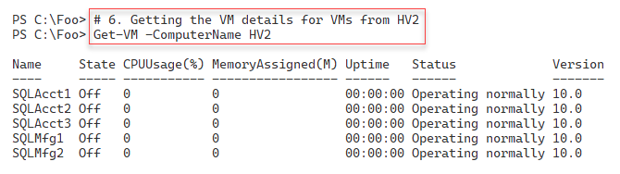

Figure 11.52: Viewing VMs on HV2

Insert image B42024_11_52.png

In step 7, you create a new VM networking switch on HV2 to enable VM networking. The output you see is as follows:

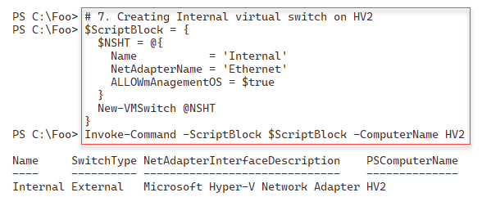

Figure 11.53: Creating a new VM switch on HV2

Insert image B42024_11_53.png

In step 8, you enable VM migration on both HV1 and HV2. In step 9, you configure Hyper-V VM migration on both servers. Next, in step 10, you perform a live migration of the PSDirect VM to HV2. These three steps produce no output.

In step 11, you display how long it took Hyper-V to migrate the PSDirect VM, with output like this:

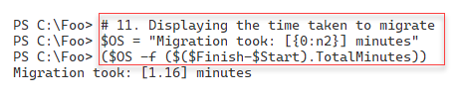

Figure 11.54: Displaying the VM migration time

Insert image B42024_11_54.png

In step 12, you use the Get-VM cmdlet to view the VMs on HV1. Since you migrated the PSDirect VM to HV2, there are no VMs on HV2. Thus, there is no console output from this step. Then, in step 13, you view the VMs on HV2, which produces output like this:

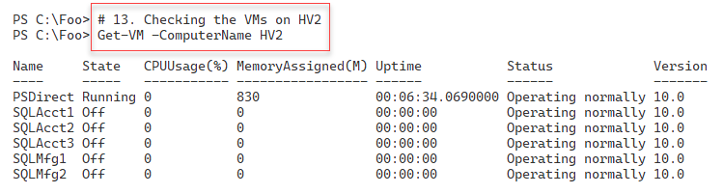

Figure 11.55: Displaying VMs on HV2

Insert image B42024_11_55.png

In step 14, you examine the details of where Hyper-V has stored the VM configuration and virtual hard drives for the PSDirect VM. The output of this step looks like this:

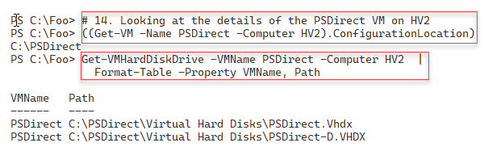

Figure 11.56: Displaying hard disks for PSDirect VM

Insert image B42024_11_56.png

In step 15 (which you run from HV2), you migrate the PSDirect VM back to HV1, producing no console output. In the final step in this recipe, step 16, you view how long it took Hyper-V to migrate the VM back to HV1, with output like this:

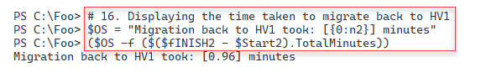

Figure 11.57: Viewing PSDirect migration time

Insert image B42024_11_57.png

## There's more...

In step 1, you check the status of the PSDirect VM to ensure it is running. If the output you see shows that the VM is not running, you should use the Start-VM cmdlet to start it before proceeding with this recipe.

In step 6, you used Get-VM to view the VMs defined on HV2. The output shows the VMs created in the earlier recipe, Using Hyper-V VM groups.

In step 13, you view the VMs on HV2, which now shows the PSDirect VM. Note that the VM has continued running since you performed a live migration. Consider opening a remote desktop connection using mstsc.exe, or use the VM Connect feature of the Hyper-V management console and open a session to the PSDirect VM. With either method, you can use and view the VM as you carry out the migration. When the migration is complete, you may need to log in to your VM session again.

# Managing VM Replication

VM replication is a disaster recovery feature within Hyper-V. Hyper-V creates a VM replica on a remote Hyper-V server and keeps that replica up to date as the original VM changes. You can make the replica active should the VM's host fail for some reason. The VM on the remote host is not active during the normal operation of the original VM.

With Hyper-V replication, the source VM host bundles up the changes in a running VM's VHD file(s) and regularly sends them to the replica server. The replica server then applies those changes to the dormant replica.

Once you have a VM replica established, you can test the replica to ensure that it can start should you need it. Also, you can failover to the replica, bringing the replicated VM up based on the most recently replicated data. If the source VM host becomes inoperable before it can replicate changes on the source VM, there is a risk of the replication process losing those changes.

In this recipe, you create and use a replica of the PSDirect VM, which you have used in previous recipes in this chapter.

## Getting ready

This recipe creates a Hyper-V VM replica of the PSDirect VM running in HV1 to HV2. You created this VM in the Creating a Hyper-V VM recipe. You also use this VM in the Managing VM and storage movement recipe. You should have loaded the Hyper-V management tools on DC1. If you have not already done so, do the following on DC1:

Install-WindowsFeature -Name RSAT-Hyper-V-Tools,Hyper-V-PowerShell |

Out-Null

## Additionally, remember that these recipes assume you have turned off any firewalls on your VMs (and host). This simplifies the environment and enables the recipe to focus on, in this case, VM replication.

## How to do it...

1. Configuring HV1 and HV2 to be trusted for delegation in AD on DC1

$ScriptBlock = {

  Set-ADComputer -Identity HV1 -TrustedForDelegation $True

  Set-ADComputer -Identity HV2 -TrustedForDelegation $True

}

Invoke-Command -ComputerName DC1 -ScriptBlock $ScriptBlock

1. Rebooting the HV1 and HV2 hosts

Restart-Computer -ComputerName HV2 -Force

Restart-Computer -ComputerName HV1 -Force

1. Configuring Hyper-V replication on HV1 and HV2

$VMReplHT = @{

  ReplicationEnabled              = $true

  AllowedAuthenticationType       = 'Kerberos'

  KerberosAuthenticationPort      = 42000

  DefaultStorageLocation          = 'C:\Replicas'

  ReplicationAllowedFromAnyServer = $true

  ComputerName                    = 'HV1.Reskit.Org',

                                    'HV2.Reskit.Org'

}

Set-VMReplicationServer @VMReplHT

1. Enabling PSDirect on HV1 to be a replica source

$VMReplicaSourceHT = @{

  VMName             = 'PSDirect'

  Computer           = 'HV1'

  ReplicaServerName  = 'HV2'

  ReplicaServerPort  = 42000

  AuthenticationType = 'Kerberos'

  CompressionEnabled = $true

  RecoveryHistory    = 5

}

Enable-VMReplication  @VMReplicaSourceHT -Verbose

1. Viewing the replication status of HV1

Get-VMReplicationServer -ComputerName HV1

1. Checking PSDirect on Hyper-V hosts

Get-VM -ComputerName HV1 -VMName PSDirect

Get-VM -ComputerName HV2 -VMName PSDirect

1. Starting the initial replication

Start-VMInitialReplication -VMName PSDirect -ComputerName HV1

1. Examining the initial replication state on HV1 just after you start the initial replication

Measure-VMReplication -ComputerName HV1

1. Examining the replication status on HV1 after replication completes

Measure-VMReplication -ComputerName HV1

1. Testing PSDirect failover to HV2

$FOScriptBlock = {

  $VM = Start-VMFailover -AsTest -VMName PSDirect -Confirm:$false

  Start-VM $VM

}

Invoke-Command -ComputerName HV2 -ScriptBlock $FOScriptBlock

1. Viewing the status of PSDirect VMs on HV2

$VMsOnHV1 = Get-VM -ComputerName HV2 -VMName PSDirect*

$VMsOnHV1

1. Examining networking on PSDirect Test VM

$TestVM = $VMsOnHV1 | Where-Object Name -Match 'Test'

Get-VMNetworkAdapter -CimSession HV2 -VMName $TestVM.Name

1. Stopping the failover test

$StopScriptBlock = {

  Stop-VMFailover -VMName PSDirect

}

Invoke-Command -ComputerName HV2 -ScriptBlock $StopScriptBlock

1. Viewing the status of VMs on HV1 and HV2 after failover stopped

Get-VM -ComputerName HV1 -VMName PSDirect*

Get-VM -ComputerName HV2 -VMName PSDirect*

1. Stopping PSDirect VM on HV1 before performing a planned failover

Stop-VM PSDirect -ComputerName HV1

1. Starting VM failover from HV1 to HV2

Start-VMFailover -VMName PSDirect -ComputerName HV2 -Confirm:$false

1. Completing the failover

$CHT = @{

  VMName       = 'PSDIrect'

  ComputerName = 'HV2'

  Confirm      = $false

}

Complete-VMFailover @CHT

1. Viewing VM Status on both Hyper-V Hosts

Get-VM -ComputerName HV1 -VMName PSDirect*

Get-VM -ComputerName HV2 -VMName PSDirect*

1. Starting the replicated VM on HV2

Start-VM -VMname PSDirect -ComputerName HV2

1. Checking PSDirect VM networking for HV2

Get-VMNetworkAdapter -ComputerName HV2 -VMName PSDirect

1. Connecting PSDirect to VM Switch

$ConnectHT = @{

  VMName       = 'PSDirect'

  ComputerName = 'HV2'

  SwitchName   = 'Internal'

}

Connect-VMNetworkAdapter @ConnectHT

1. Checking PSDirect VM networking for HV2

Get-VMNetworkAdapter -ComputerName HV2 -VMName PSDirect

## How it works...

In step 1, you configure HV1 and HV2 to be trusted for delegation as required to support VM replication, and then in step 2, you reboot both hosts to complete the process of trusting these hosts for delegation. These two steps produce no console output.

After rebooting both hosts, in step 3, you configure both Hyper-V hosts to support VM replication. In step 4, you set up a Hyper-V replication partnership between HV1 and HV2. These two steps create no output.

In step 5, you review the replication status of the HV1 Hyper-V host, which creates output like this:

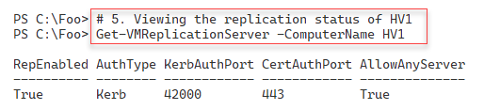

Figure 11.58: Viewing the replication status of HV1

Insert image B42024_11_58.png

Next, in step 6, you check the replication status of the PSDirect VM, which you do on both Hyper-V servers. The output of this step looks like this:

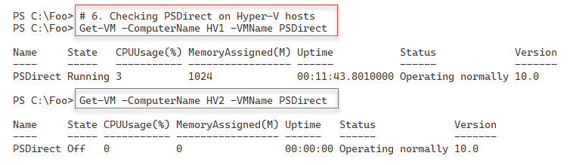

Figure 11.59: Checking the PSDirect VM status on HV1 and HV2

Insert image B42024_11_59.png

In step 7, you start the VM replication process. This step involves Hyper-V creating a duplicate VM on HV2, essentially a full copy of the PSDirect VM. This step produces no output.

If you run step 8 immediately after completing step 7, you can observe the initial replication process. You should see output like this:

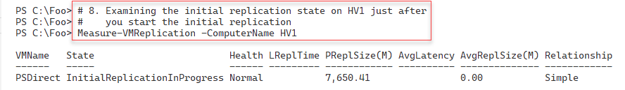

Figure 11.60: Viewing the replication process

Insert image B42024_11_60.png

The initial replication process should take a few minutes. However, the replication speed also depends on the Hyper-V host hardware components, VM memory and virtual processors, and the underlying network and disk subsystem speeds. The disk sizes of a VM’s virtual disks are also a significant factor in the initial replication speed. After Hyper-V completes the initial replication of PSDirect, you can view the replication status, as shown in step 9. The output of this step looks like this:

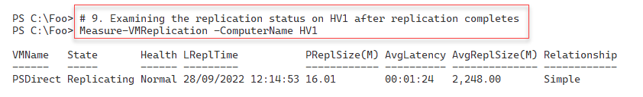

Figure 11.61: Viewing the replication once the initial replication is complete

Insert image B42024_11_61.png

Once the PSDirect replication is invoked, and Hyper-V has completed an initial replication, you can test the failover capability. In step 10, you run a test failover of the PSDirect VM from HV1 to HV2. This step generates no console output.

In step 11, you view the status of the PSDirect VMs on HV2, with output like this:

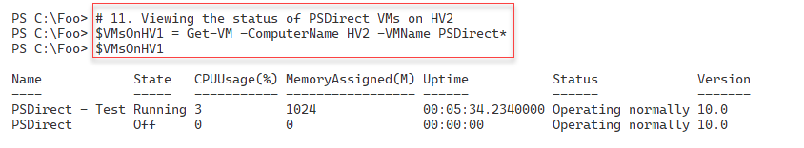

Figure 11.62: Viewing PSDirect VMs on HV2

Insert image B42024_11_62.png

In step 12, you examine the networking in the PSDirect test VM with output like this:

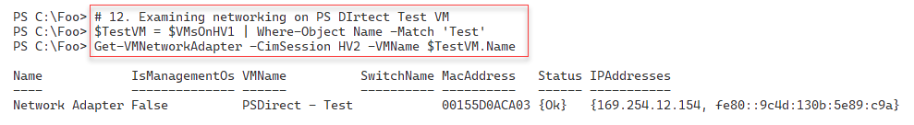

Figure 11.63: Viewing the status of PSDirect Networking

Insert image B42024_11_63.png

In step 13, you stop the PSDirect VM before carrying out a *planned* failover. Next, in step 15, you perform the planned failover of PSDirect from HV1 to HV2. Once you have initiated the planned failover (that is, once the cmdlet completes), in step 16, you complete the VM failover process. In step 17, you start the PSDirect VM on HV2. These four steps produce no console output.

In step 18, you check the status of the PSDirect VM on both Hyper-V hosts. This step generates the following output:

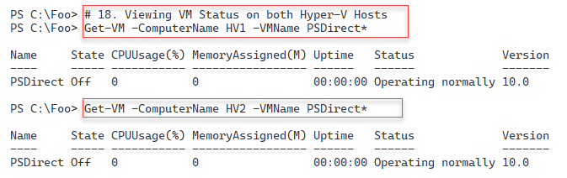

Figure 11.64: Checking the VM status of PSDirect on both Hyper-V Hosts

Insert image B42024_11_64.png

In step 19, you start the PSDirect VM on the HV2 Hyper-V host. This step creates no output. In step 20, you check the networking for the PSDirect VM with output like this:

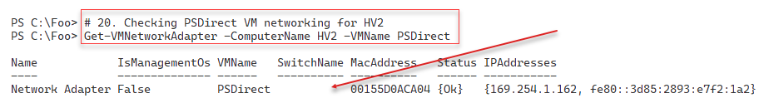

Figure 11.65: Checking the VM networking on PSDirect

Insert image B42024_11_64.png

In step 20, you add the NIC in the PSDirect VM into the Internal VM switch on HV2, creating no console output. In step22, you re-check the networking on PSDirect with output like this:

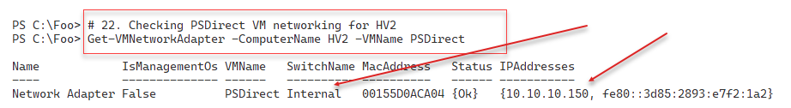

Figure 11.66: Checking the VM networking on PSDirect

Insert image B42024_11_66.png

## There's more...

In step 11, you view the two PSDirect VMs on HV2. The first is the VM that you are replicating from HV1. During this step, PSDirect is up and running on HV1 and replicating any changes to HV2. You see a separate test VM showing that the replica VM is up and running on HV2. It is always good to run a test failover after setting up replication to ensure that the replication and failover work as you wish.

In step 18, you view the PSDirect VM status on both of your Hyper-V hosts. As you can see in the output from this step, Figure 12.64, the PSDirect VM is up and running on HV2. On HV1, you still have an (older) copy of the VM with the VM failed over (and running) on HV2.

# Managing VM Checkpoints

With Hyper-V in Server 2022, a checkpoint captures the state of a VM into a restore point. Hyper-V then enables you to roll back a VM to a checkpoint. Windows Server 2008's version of Hyper-V provided this feature, although these restore points were called snapshots at that time.

With Server 2012, Microsoft changed the name to “checkpoint.” This terminology change was consistent with System Center and avoided confusion with respect to the Volume Shadow Copy Service (VSS) snapshots used by many backup systems. While the Hyper-V team did change the terminology, some of the cmdlet names remain unchanged. For instance, to restore a VM to a checkpoint, you use the Restore-VMSnapshot cmdlet.

You can create a variety of checkpoints for a VM. When you create a checkpoint, Hyper-V temporarily pauses the VM. Hyper-V creates a new differencing disk (AVHD). Hyper-V then resumes the VM, which writes all data to the differencing disk.

Checkpoints are excellent for a variety of scenarios. They can be helpful in troubleshooting. You can get the VM to the point where some bug is triggered and take a checkpoint. Then you can try a fix—if it doesn't work, you can just roll the VM back to the checkpoint and try another fix. Checkpoints are also helpful for training. You could create a VM where you perform all the lab exercise steps and create a checkpoint after each successful lab. That way, the student can make a mistake in a lab exercise and skip forward to a later checkpoint to carry on.

Using checkpoints in production is a different matter. In general, you should avoid using checkpoints on your production systems for several reasons. If your servers use any replication or transaction-based applications, the impact of rolling back a VM to an earlier time can lead to issues. Since checkpoints rely on differencing disks that feature constantly growing physical disk files, using checkpoints can also result in poor performance.

In this recipe, you create a checkpoint of the PSDirect VM, and then you create a file inside the VM. You take a further checkpoint and create a second file. Then you revert to the first checkpoint, observing that there are no files(thus far) created. You roll forward to the second checkpoint to see that the first file is there but not the second (because you created the second file after taking the checkpoint). Then you remove all the checkpoints. After each checkpoint operation, you observe the VHDX and AVHD files that Hyper-V uses in the PSDirect VM.

## Getting ready

You run this recipe on HV1. This recipe uses the PSDirect VM you created and used earlier in this chapter. Depending on which other recipes you have run from this chapter, the virtual disks may be in different folders, but the recipe copes with the disk files in any folder known to Hyper-V.

## How to do it...

1. Ensuring PSDirect VM is running

$VMState = Get-VM -VMName PSDirect | Select-Object -ExpandProperty State

If ($VMState -eq 'Off') {

  Start-VM -VMName PSDirect

}

1. Creating credentials for PSDirect

$RKAdmin     = 'Wolf\Administrator'

$Pass        = 'Pa$$w0rd'

$RKPassword  =

    ConvertTo-SecureString -String $Pass -AsPlainText -Force

$RKCred = [System.Management.Automation.PSCredential]::new(

    $RKAdmin,$RKPassword)

1. Examining the C:\ in the PSDirect VM before we start

$ScriptBlock = { Get-ChildItem -Path C:\ | Format-Table}

$InvocationHT = @{

  VMName      = 'PSDirect'

  ScriptBlock = $ScriptBlock

  Credential  = $RKCred

}

Invoke-Command @InvocationHT

1. Creating a checkpoint of PSDirect on HV1

$CPHT = @{

  VMName       = 'PSDirect'

  ComputerName = 'HV1'

  SnapshotName = 'Snapshot1'

}

Checkpoint-VM @CPHT

1. Examining the files created to support the checkpoints

$Parent = Split-Path -Parent (Get-VM -Name PSdirect |

            Select-Object -ExpandProperty HardDrives).Path |

              Select-Object -First 1

Get-ChildItem -Path $Parent

1. Creating some content in a file on PSDirect and displaying it

$ScriptBlock = {

  $FileName1 = 'C:\File_After_Checkpoint_1'

  Get-Date | Out-File -FilePath $FileName1

  Get-Content -Path $FileName1

}

$InvocationHT = @{

  VMName      = 'PSDirect'

  ScriptBlock = $ScriptBlock

  Credential  = $RKCred

}

Invoke-Command @InvocationHT

1. Taking a second checkpoint

$SecondChkpointHT = @{

  VMName        = 'PSDirect'

  ComputerName  = 'HV1'

  SnapshotName  = 'Snapshot2'

}

Checkpoint-VM @SecondChkpointHT

1. Viewing the VM checkpoint details for PSDirect

Get-VMSnapshot -VMName PSDirect

1. Looking at the files supporting the two checkpoints

Get-ChildItem -Path $Parent

1. Creating and displaying another file in PSDirect

$ScriptBlock2 = {

  $FileName2 = 'C:\File_After_Checkpoint_2'

  Get-Date | Out-File -FilePath $FileName2

  Get-ChildItem -Path C:\ -File | Format-Table

}

$InvocationHT2 = @{

  VMName    = 'PSDirect'

  ScriptBlock = $ScriptBlock2

  Credential  = $RKCred

}

Invoke-Command @InvocationHT2

1. Restoring the PSDirect VM back to the checkpoint named Snapshot1

$Snap1 = Get-VMSnapshot -VMName PSDirect -Name Snapshot1

Restore-VMSnapshot -VMSnapshot $Snap1 -Confirm:$false

Start-VM -Name PSDirect

Wait-VM -For IPAddress -Name PSDirect

1. Seeing what files we have now on PSDirect

$ScriptBlock3 = {

  Get-ChildItem -Path C:\ | Format-Table

}

$InvocationHT3 = @{

  VMName     = 'PSDirect'

  ScriptBlock = $ScriptBlock3

  Credential  = $RKCred

}

Invoke-Command @InvocationHT3

1. Rolling forward to Snapshot2

$Snap2 = Get-VMSnapshot -VMName PSdirect -Name Snapshot2

Restore-VMSnapshot -VMSnapshot $Snap2 -Confirm:$false

Start-VM -Name PSDirect

Wait-VM -For IPAddress -Name PSDirect

1. Observe the files you now have supporting PSDirect

$ScriptBlock4 = {

    Get-ChildItem -Path C:\ | Format-Table

}

$InvocationHT4 = @{

  VMName      = 'PSDirect'

  ScriptBlock = $ScriptBlock4

  Credential  = $RKCred

}

Invoke-Command @InvocationHT4

1. Restoring to Snapshot1 again

$Snap1 = Get-VMSnapshot -VMName PSDirect -Name Snapshot1

Restore-VMSnapshot -VMSnapshot $Snap1 -Confirm:$false

Start-VM -Name PSDirect

Wait-VM -For IPAddress -Name PSDirect

1. Checking checkpoints and VM data files again

Get-VMSnapshot -VMName PSDirect

Get-ChildItem -Path $Parent | Format-Table

1. Removing all the checkpoints from HV1

Get-VMSnapshot -VMName PSDirect |

  Remove-VMSnapshot

1. Checking VM data files again

Get-ChildItem -Path $Parent

## How it works...

In step 1, you ensure that the PSDirect VM is running (on HV1). Next, in step 2, you create a Windows credential object to use when invoking script blocks inside the PSDirect VM. These steps create no console output.

In step 3, using the credential object you created earlier, you invoke a script block that examines the C:\ drive inside the PSDirect VM. This step creates output like this:

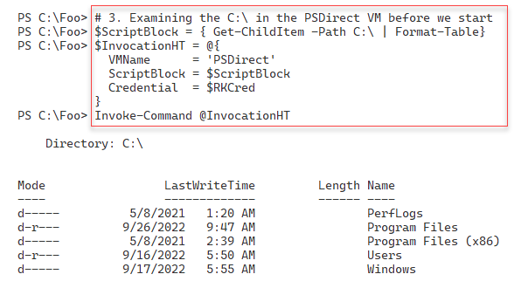

Figure 11.67: Viewing the C:\ drive inside the PSDirect VM

Insert image B42024_11_67.png

In step 4, you use the Checkpoint-VM cmdlet to create a new VM checkpoint which you name Snapshot1. This step creates no output.

With step 5, you determine where Hyper-V has stored the virtual disks for the PSDirect VM, and then you display the associated files with output like this:

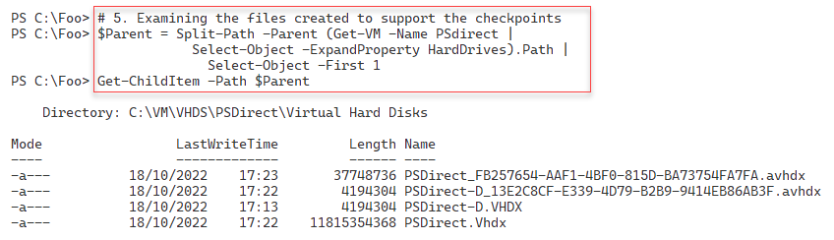

Figure 11.68: Examining files supporting a checkpoint

Insert image B42024_11_68.png

In step 6, you create a new file on the C:\ drive in the PSDirect VM. Then you view the contents of this file. The output looks like this:

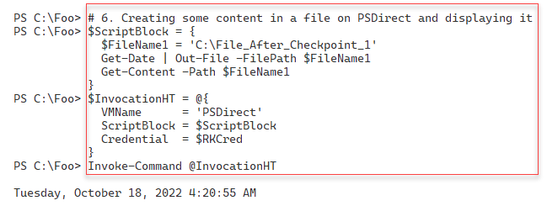

Figure 11.69: Creating a file in the PSDirect VM

Insert image B42024_11_69.png

After creating a file inside the VM, in step 7, you create a second checkpoint that generates no output. In step 8, you use the Get-VMSnapshot cmdlet to view the checkpoint for the PSDirect VM currently on HV1, which looks like this:

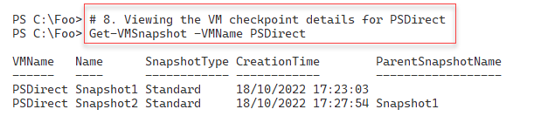

Figure 11.70: Viewing snapshots of the PSDirect VM

Insert image B42024_11_70.png

In step 9, you examine again the files that Hyper-V uses to store your virtual disk images and both sets of checkpoint files for the PSDirect VM, like this:

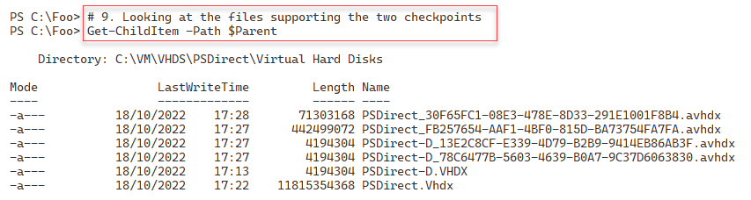

Figure 11.71: Viewing snapshots of the PSDirect VM

Insert image B42024_11_71.png

In step 10, you create a new file in the PSDirect VM, add contents to the file, and then view those files created so far like this:

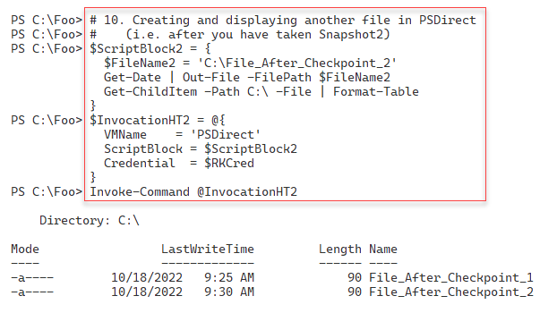

Figure 11.72: Creating a second file in PSDirect

Insert image B42024_11_72.png

In step 11, you revert the PSDirect VM back to the first checkpoint (i.e., Snapshot1), which creates no output to the console. In step 12, you see what files you now have on the C:\ drive (after you have reverted to the earlier checkpoint), with output like this:

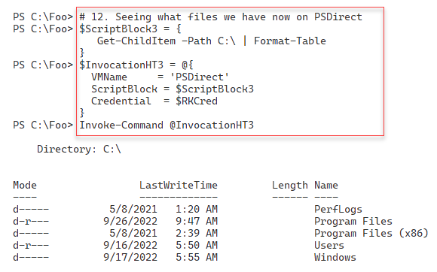

Figure 11.73: Checking files in PSDirect

Insert image B42024_11_73.png

In step 13, you roll forward the PSDirect VM to the second checkpoint, which creates no output. In step 14, you examine the files created in PSDirect (in the second checkpoint), which looks like this:

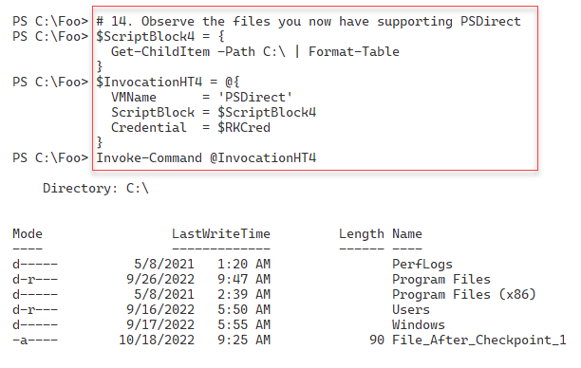

Figure 11.74: Checking files in PSDirect after restoring Snapshot2

Insert image B42024_11_74.png

In step 15, you restore PSDirect to the first checkpoint, a step that creates no console output. In step 16, you check the checkpoints and the virtual disk files again, with output like this:

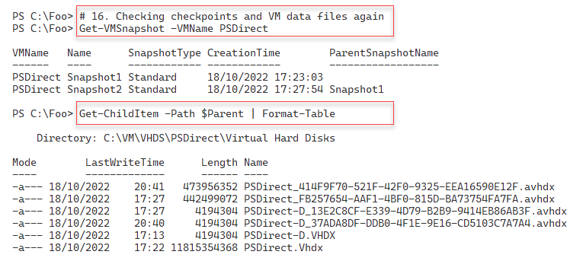

Figure 11.75: Checking the checkpoints on HV1

Insert image B42024_11_75.png

In step 17, you remove all the checkpoints for PSDirect on HV1, which generates no output to the console. In the final step in this recipe, step 18, you check the VM data files on HV1, which produces the following output:

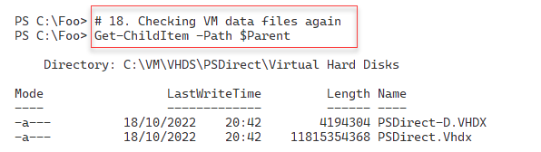

Figure 11.76: Viewing disk files after removing the checkpoints for PSDirect VM

Insert image B42024_11_76.png

## There's more...

In step 9, you examine the files that Hyper-V uses to support the PSDirect VM checkpoints. The first VHDX file holds the starting state when you took the first checkpoint. Then, you see another AVHDX file (one per virtual disk in the VM) representing the state post the second snapshot. You have snapshot AVHDX files for both virtual disks, representing any work you have done after taking a checkpoint and before taking another.

In step 10, you view the two files you created in the PSDirect VM. After reverting to the first checkpoint, in step 12, you see that neither of the two files you created exists on the C:\ drive. This is because you created those files after creating the first checkpoint. This situation is the expected result of restoring a checkpoint. It also illustrates you need to take care when reverting to a snapshot, as you can lose work.

A final point about checkpoints/snapshots – this is a great bit of technology but is not a long-term backup or recovery strategy. Backup products, such as VEAAM, can take a snapshot of a VM and back up the now-static VHDX. Once the backup is complete, you remove the snapshot and allow Hyper-V to merge any updates back into the base disk.

# Creating a Hyper-V Report

Your Hyper-V hosts are almost certainly mission-critical. Indeed, any Hyper-V host you deploy is critical to your IT infrastructure. If the Hyper-V host goes down or starts suffering performance or capacity issues, it can affect all the VMs running on that host.

If you deploy Hyper-V, you must report on and monitor the health of your HyperV host, as well as the health of the VMs. By monitoring the reports, you can detect issues before they become critical. If your VM host, for example, has a slowly increasing CPU load, you can consider moving a VM to another VM host.

Reports that you use to monitor the health of a Hyper-V host fall into two broad categories: First, details about the VM host itself. Secondly, you need to monitor the VMs running on that host. This recipe creates a report containing both sets of information

## Getting ready

This recipe runs on the Hyper-V host HV1. The host should be set up as per the Installing and configuring Hyper-V feature recipe. This host should be up and running and have one VM defined and running. The VM is PSDirect which you created in the Creating a virtual machine recipe.

## How to do it...

1. Creating a basic report object hash table

$ReportHT = [Ordered] @{}

1. Adding host details to the report hash table

$HostDetails = Get-CimInstance -ClassName Win32_ComputerSystem

$ReportHT.HostName = $HostDetails.Name

$ReportHT.Maker = $HostDetails.Manufacturer

$ReportHT.Model = $HostDetails.Model

1. Adding the PowerShell and OS version information

$ReportHT.PSVersion = $PSVersionTable.PSVersion.tostring()

$OS = Get-CimInstance -Class Win32_OperatingSystem

$ReportHT.OSEdition    = $OS.Caption

$ReportHT.OSArch       = $OS.OSArchitecture

$ReportHT.OSLang       = $OS.OSLanguage

$ReportHT.LastBootTime = $OS.LastBootUpTime

$Now = Get-Date

$UpdateTime = [float] ("{0:n3}" -f (($Now -$OS.LastBootUpTime).Totaldays))

$ReportHT.UpTimeDays = $UpdateTime

1. Adding a count of processors in the host

$ProcessorHT = @{

    ClassName  = 'MSvm_Processor'

    Namespace = 'root/virtualization/v2'

}

$Proc = Get-CimInstance @ProcessorHT

$ReportHT.CPUCount = ($Proc |

  Where-Object elementname -match 'Logical Processor').Count

1. Adding the current host CPU usage

$ClassName = 'Win32_PerfFormattedData_PerfOS_Processor'

$CPU = Get-CimInstance  -ClassName $ClassName |

         Where-Object Name -eq '_Total'   |

           Select-Object -ExpandProperty PercentProcessorTime

$ReportHT.HostCPUUsage = $CPU

1. Adding the total host physical memory

$Memory = Get-Ciminstance -Class Win32_ComputerSystem

$HostMemory = [float] ( "{0:n2}" -f ($Memory.TotalPhysicalMemory/1GB))

$ReportHT.HostMemoryGB = $HostMemory

1. Adding the memory allocated to VMs

$Sum = 0

Get-VM | Foreach-Object {$sum += $_.MemoryAssigned + $Total}

$Sum = [float] ( "{0:N2}" -f ($Sum/1gb) )

$ReportHT.AllocatedMemoryGB = $Sum

1. Creating a report header object

$HostDetails = $ReportHT | Format-Table | Out-String

1. Creating two new VMs to populate the VM report

New-VM -Name VM2 | Out-Null

New-VM -Name VM3 | Out-Null

1. Getting VM details on the local VM host

$VMs = Get-VM -Name *

$VMDetails = @()

1. Getting VM details for each VM

Foreach ($VM in $VMs) {

  # Create VM Report hash table

    $VMReport = [ordered] @{}

  # Add VM's Name

    $VMReport.VMName    = $VM.VMName

  # Add Status

    $VMReport.Status    = $VM.Status

  # Add Uptime

    $VMReport.Uptime     = $VM.Uptime

  # Add VM CPU

    $VMReport.VMCPUUsage = $VM.CPUUsage

  # Replication Mode/Status

    $VMReport.ReplMode   = $VM.ReplicationMode

    $VMReport.ReplState  = $Vm.ReplicationState

  # Creating object from Hash table, adding to array

    $VMR = New-Object -TypeName PSObject -Property $VMReport

    $VMDetails += $VMR

}

1. Getting the array of VM objects as a table

$VMReportDetails =

  $VMDetails |

    Sort-Object -Property VMName |

        Format-Table |

          Out-String

1. Creating final Report

$Report  = "VM Host Details: `n" +

           $HostDetails  +

           "`nVM Details: `n" +

           $VMReportDetails

1. Displaying final report

$Report

## How it works...

Except for the final step, none of the steps in this recipe produce console outout.

In step 1, you create a report hash table to collect details about the Hyper-V host. In step 2, you add host details to this hash table. In step 3, you add the PowerShell and operating system details. In step 4, you add a count of processors in the Hyper-V host.

In step 5, you add the current hosts’ CPU utilization to the hash table. In step 6, you add the total physical memory of the host. In step 7, you add the memory allocated to VMs. Then in step 8, you create the first part of the Hyper-V report containing host system details.

In step 9, you create two new VMs to HV1 to add some additional content to the final report. In step 10, you collect the details of each VM and create a new hash table.

In step 11, you collect details of each VM and add this to the $VMDetails array. In step 12, you convert this array into a report fragment. With step 13, you create the final report adding the details about the host and the details of each VM.

In the final step, step 14, you display the report, which looks like this:

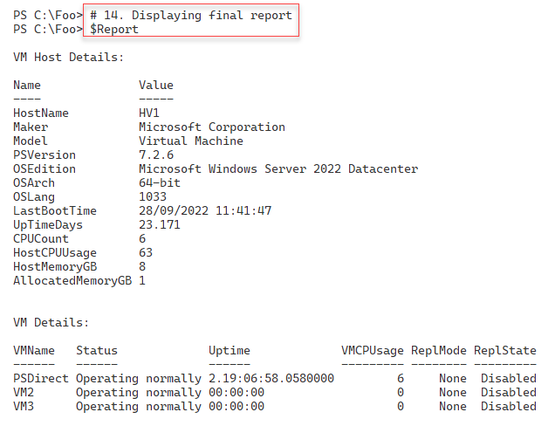

Figure 11.77: Viewing disk files after removing the checkpoints for PSDirect VM

Insert image B42024_11_77.png

## There's more...

This recipe uses various methods to obtain key performance and usage metrics. Once this information is retrieved, the recipe converts this information into an object which you can then display.

The recipe first creates a report object containing the VM host's details. Then the recipe gets key information about each VM and creates an object for each VM on the host, which the recipe adds to the overall Hyper-V report. At the end of the recipe, you display the combined report. This approach lets you sort and filter the objects to create whatever reporting you need. The technique used here is to create hash tables holding host and VM details and then to turn these hash tables into fully-fledged objects.

This recipe reports some, but not all, the details of the host or VMs. You can adjust either part of the recipe to add (or remove) details from the report.

In step 14, you viewed a report of the HV1 Hyper-V host running a limited set of VMs. On a busier and larger system, this report might look like this:

Figure 11.78: Viewing the report on a real Hyper-V host

Insert image B42024_11_78.png